LIFE SKILLS – FACING FREEDOM
Important Connections for Your New Life

Opening Thoughts
There are many issues to face as you prepare to leave a jail or prison…
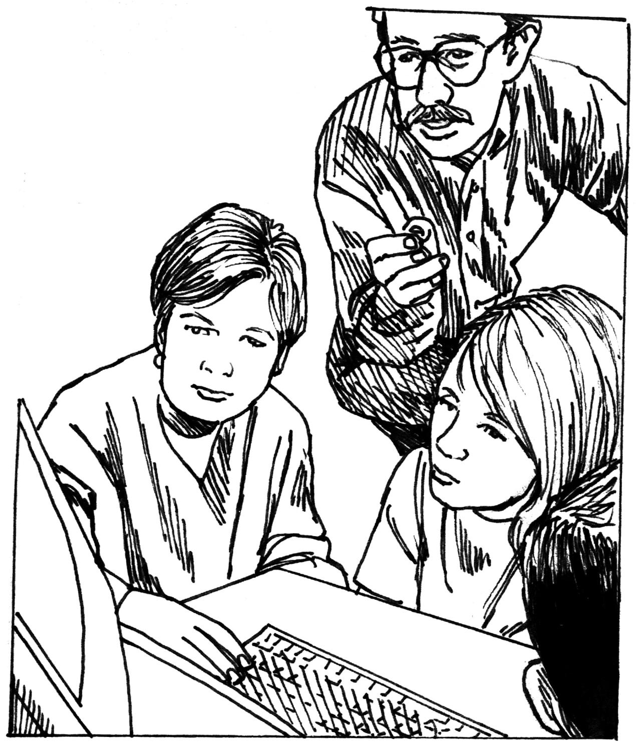
- reconnection with your family…
  - Will your family be there for you?
  - How will you learn to live independently if your family has disowned you?
- finding employment…
  - Why should an employer hire you?
- learning how to manage your hard-earned dollars…

  - What kind of plan do you need to have in place?
  - What are the priorities for the money you earn?
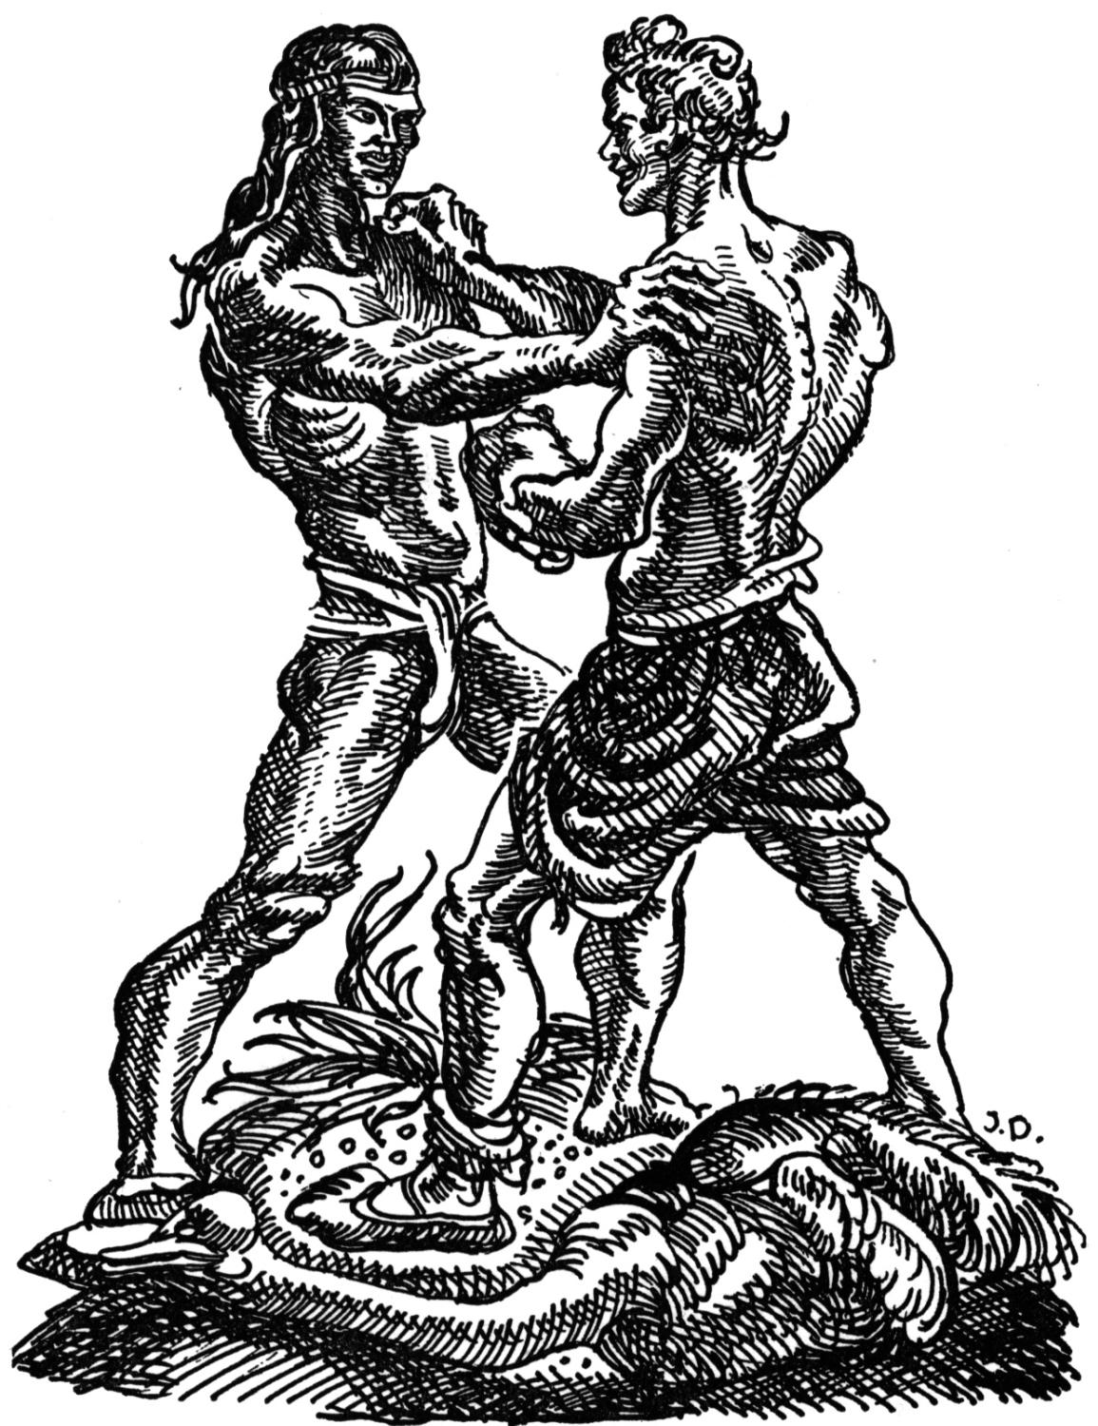
- staying away from your former, destructive friends…
  - How will you avoid those friends?
  - What will you tell that person if he/she wants a relationship with you?

- thinking positive thoughts…
  - How will you avoid negative and/or hateful thoughts?

Question: Which of these five issues listed above is most pressing as you face freedom?

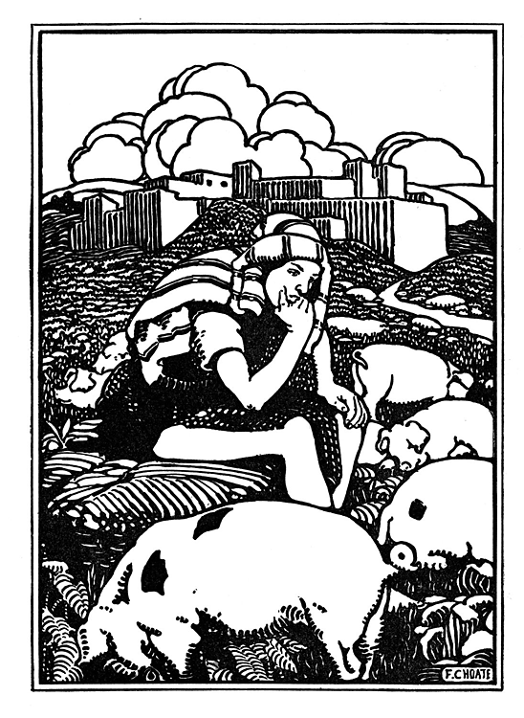
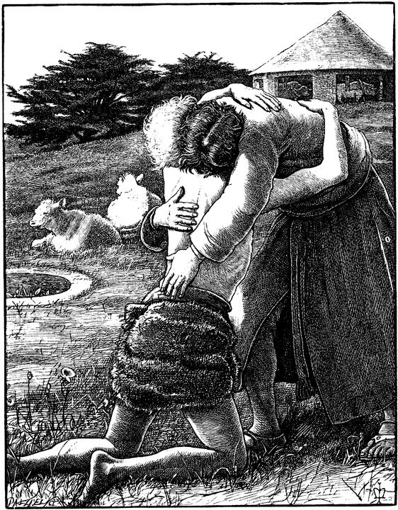
The example of the Lost Son: Read Luke 15:11-31: ¹¹ Jesus continued, "There was a man who had two sons. ¹² The younger son spoke to his father. He said, 'Father, give me my share of the family property.' So the father divided his property between his two sons. ¹³ "Not long after that, the younger son packed up all he had. Then he left for a country far away. There he wasted his money on wild living. ¹⁴ He spent everything he had. "Then the whole country ran low on food. So the son didn't have what he needed. ¹⁵ He went to work for someone who lived in that country, who sent him to the fields to feed the pigs. ¹⁶ The son wanted to fill his stomach with the food the pigs were eating. But no one gave him anything. ¹⁷ "Then he began to think clearly again. He said, 'How many of my father's hired workers have more than enough food! But here I am dying from hunger! ¹⁸ I will get up and go back to my father. I will say to him, "Father, I have sinned against heaven. And I have sinned against you. ¹⁹ I am no longer fit to be called your son. Make me like one of your hired workers."' ²⁰ So he got up and went to his father. "While the son was still a long way off, his father saw him. He was filled with tender love for his son. He ran to him. He threw his arms around him and kissed him. ²¹ "The son said to him, 'Father, I have sinned against heaven and against you. I am no longer fit to be called your son.' ²² "But the father said to his servants, 'Quick! Bring the best robe and put it on him. Put a ring on his finger and sandals on his feet. ²³ Bring the fattest calf and kill it. Let's have a big dinner and celebrate. ²⁴ This son of mine was dead. And now he is alive again. He was lost. And now he is found.'" So they began to celebrate. ²⁵ "The older son was in the field. When he came near the house, he heard music and dancing. ²⁶ So he called one of the servants. He asked him what was going on. ²⁷ " 'Your brother has come home,' the servant replied. 'Your father has killed the fattest calf. He has done this because your brother is back safe and sound.' ²⁸ "The older brother became angry. He refused to go in. So his father went out and begged him. ²⁹ "But he answered his father, 'Look! All these years I've worked like a slave for you. I have always obeyed your orders. You never gave me even a young goat so I could celebrate with my friends. ³⁰ But this son of yours wasted your money with some prostitutes. Now he comes home. And for him you kill the fattest calf!' ³¹ " 'My son,' the father said, 'you are always with me. Everything I have is yours.

Understanding the Lost Son account
1. Why was the young man so interested in leaving home? What were the likely attractions?

2. How much money do you think his father gave to him?

3. What did he end up doing to survive?

Application to our lives
4. As you think about this account of a rebellious son, of what does this remind you in your own life?

5. Does it appear that the young man really enjoyed his new life? Explain.

6. What makes the life-on-the-run (e.g., the “wild life,” the misuse of drugs and/or alcohol) so damaging to a person’s life?

7. As you think about the way in which the son’s father welcomed him back into the household, did you ever experience something like that?

8. The father in the Lost Son account is a picture of the loving relationship that God has for every person on earth. However, not everyone understands, nor appreciates God’s love. What happens when a person comes to know God and Jesus Christ as his or her personal Savior?

9. What are some of the blessings God has given you?

10. How will ask God to help you secure a job, assist you to re-connect with your family, keep you from going back to your former destructive friends, and keep you thinking positive thoughts? How often?

Closing Prayer

Additional reading: “Facing Freedom” (WELS Prison Ministry)
Optional reading: Genesis 27:1-36 – The self-centered behavior of Jacob, the grandson of Abraham.

Scripture taken from the Holy Bible, NEW INTERNATIONAL READER'S VERSION®.Copyright © 1996, 1998 Biblica. All rights reserved throughout the world. Used by permission of Biblica.

Adapted from a Bible study originally prepared by Duane Anderson (2010).

