LIFE SKILLS – HOMELESSNESS AND DESPAIR
God Does Take Care of Us!

OPENING PRAYER:
Heavenly Father, we ask you to send your Holy Spirit to be with us as we study your holy Word. Grant us understanding so that we can appreciate what you went through for us – your perfect life and your perfect death as an all-atoning death for us. What a wonderful gift you have made available for each of us! Help us to encourage others who are needy. May those who do not believe come to believe in you, and trust in you for of their needs. In Jesus’ name. Amen!

OPENING THOUGHTS:

- When you think of home, what is “home” to you?
- What does the Lord call home?
- Is it possible to feel “at home” wherever you are?
- Why is it so difficult to trust that God will provide for all your needs?

BIBLE STUDY:
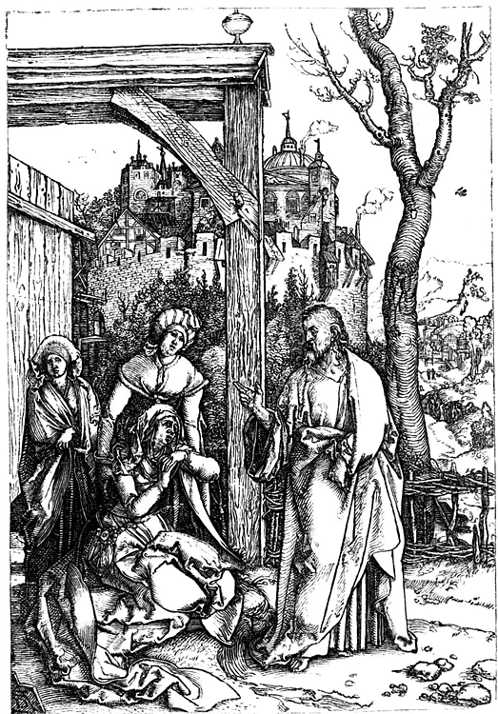
Read Luke 9:58: Jesus replied, "Foxes have holes. Birds of the air have nests. But the Son of Man has no place to lay his head."
- Where did Jesus live?

- How important is it to worry about what you will eat, drink, and wear or where you are going to live?

Read Luke 12:22-34: Do Not Worry

²² Then Jesus spoke to his disciples. He said, "I tell you, do not worry. Don't worry about your life and what you will eat. And don't worry about your body and what you will wear. ²³ There is more to life than eating. There are more important things for the body than clothes. ²⁴ "Think about the ravens. They don't plant or gather crops. They don't have any storerooms at all. But God feeds them. You are worth much more than birds! ²⁵ "Can you add even one hour to your life by worrying? ²⁶ You can't do that very little thing. So why worry about the rest? ²⁷ "Think about how the lilies grow. They don't work or make clothing. But here is what I tell you. Not even Solomon in all of his glory was dressed like one of those flowers. ²⁸ If that is how God dresses the wild grass, how much better will he dress you! After all, the grass is here only today. Tomorrow it is thrown into the fire. Your faith is so small! ²⁹ "Don't spend time thinking about what you will eat or drink. Don't worry about it. ³⁰ People who are ungodly run after all of those things. Your Father knows that you need them. ³¹ "But put God's kingdom first. Then those other things will also be given to you. ³² "Little flock, do not be afraid. Your Father has been pleased to give you the kingdom. ³³ Sell what you own. Give to those who are poor. Provide purses for yourselves that will not wear out. Put away riches in heaven that will not be used up. There, no thief can come near it. There, no moth can destroy it. ³⁴ Your heart will be where your riches are.

- What does God tell us about his interest in our lives?

- What important belief does God want us to hold on to?

- In God’s view, where is home?

Read Luke 4:1-2: ¹ Jesus, full of the Holy Spirit, returned from the Jordan River. The Spirit led him into the desert. ² There the devil tempted him for 40 days.
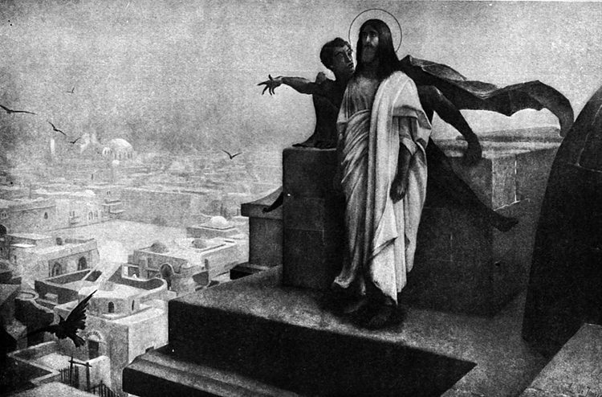
- Because Jesus was successful in overcoming Satan’s temptation, what does that tell us about his nature as God and man?

- How can you deal with the temptations that face you in your life?

- When the Children of Israel were in the desert they were hungry, thirsty and homeless. How did God take care of them?

- How can (is) the Lord take (taking) care of you today?

- Are you willing to share a situation in your life where things seemed hopeless but the Lord provided for you?

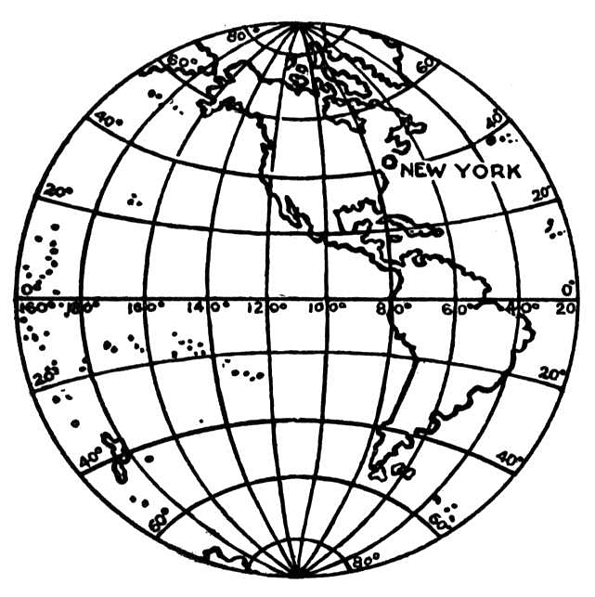
Read John 15:19: “If you belonged to the world, it would love you like one of its own. But you do not belong to the world. I have chosen you out of the world. That is why the world hates you.”
- Why is it important that we not worry too much about the needs and concerns of this world?

- What happens when we let worry take over our lives?

- What have you learned from this Bible study that changed your outlook on life?

CLOSING PRAYER:
What a wonderful, caring God we have! Lord, help us remember that no matter how difficult our situation in life is you are watching over us. Help us always to remember that you are the strong rock in our lives, that you are the light of our lives, and that you are the reason we have to live. Thank you for providing for us here while we wander through life and providing heaven for us so that we may live forever with you. In Jesus’ name. Amen.

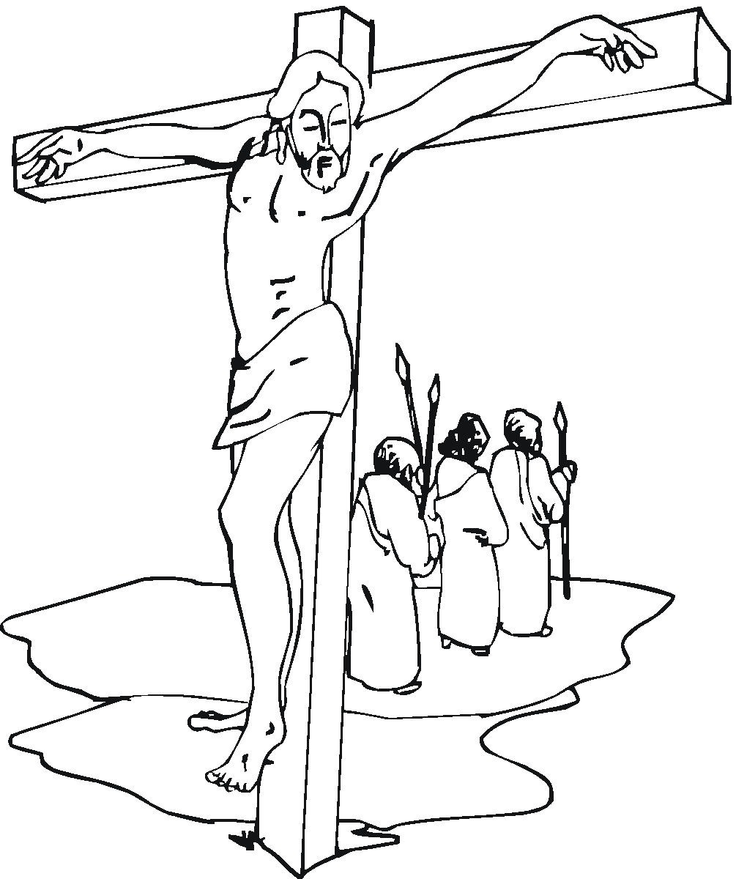

Scripture taken from the Holy Bible, NEW INTERNATIONAL READER'S VERSION®.Copyright © 1996, 1998 Biblica. All rights reserved throughout the world. Used by permission of Biblica.

Adapted from a Bible study originally prepared by Duane Anderson (no date).

