APPRECIATING GOD’S GLORY AND GOD’S HEAVEN
See the Glory and Radiance of Our God!

OPENING PRAYER

INTRODUCTION: There are more than a few places in the Bible where the spectacular, awesome nature of God is revealed, although still only in a partial way. We need to appreciate the perfection, holiness, radiance and awe which surrounds our all-powerful God and his heaven!

LOOK AT THE BIBLE, GOD’S WORD:
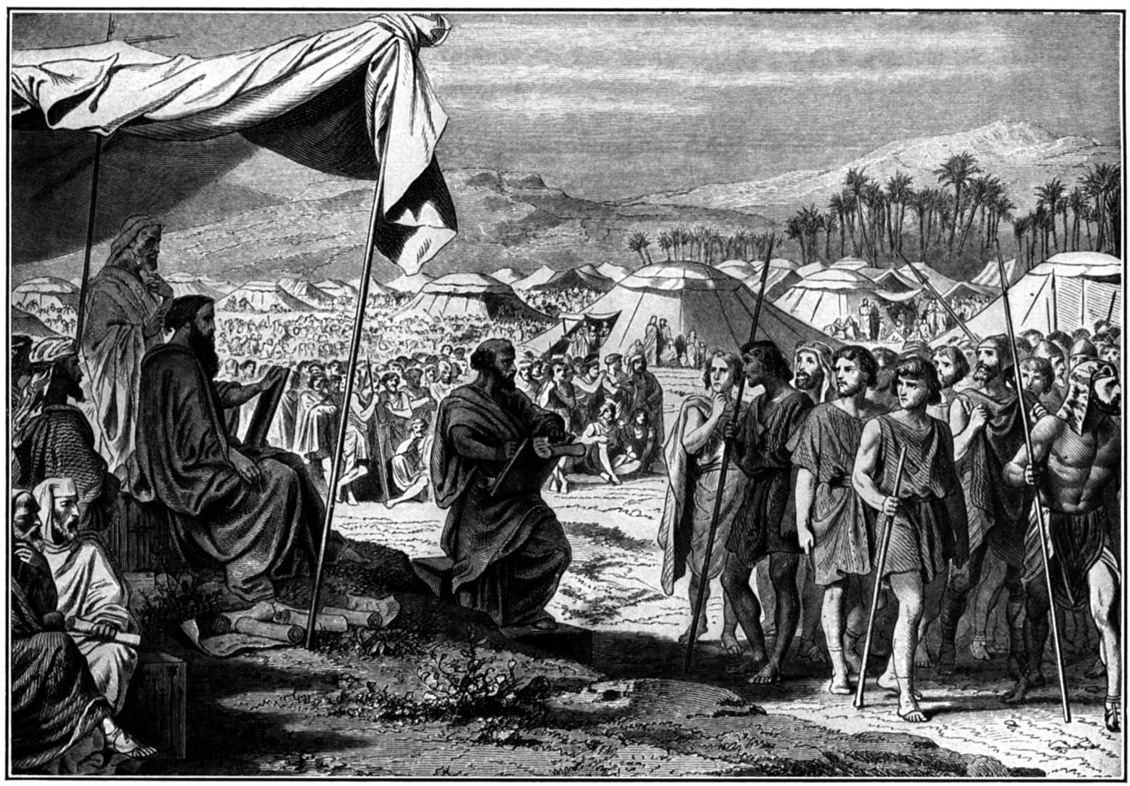
- Exodus 34:29-35: The Face of Moses Shines ²⁹ Moses came down from Mount Sinai. He had the two tablets of the covenant in his hands. His face was shining because he had spoken with the Lord. But he didn't realize it. ³⁰ Aaron and all of the people of Israel saw Moses. His face was shining. So they were afraid to come near him. ³¹ But Moses called out to them. So Aaron and all of the leaders of the community came to him. And Moses spoke to them. ³² After that, all of the people came near him. And he gave them all of the commands the Lord had given him on Mount Sinai. ³³ Moses finished speaking to them. Then he put a veil over his face. ³⁴ But when he would go to speak with the Lord, he would remove the veil. He would keep it off until he came out. Then he would tell the people what the Lord had commanded. ³⁵ They would see that his face was shining. So Moses would put the veil back over his face. He would keep it on until he went in again to speak with the Lord.
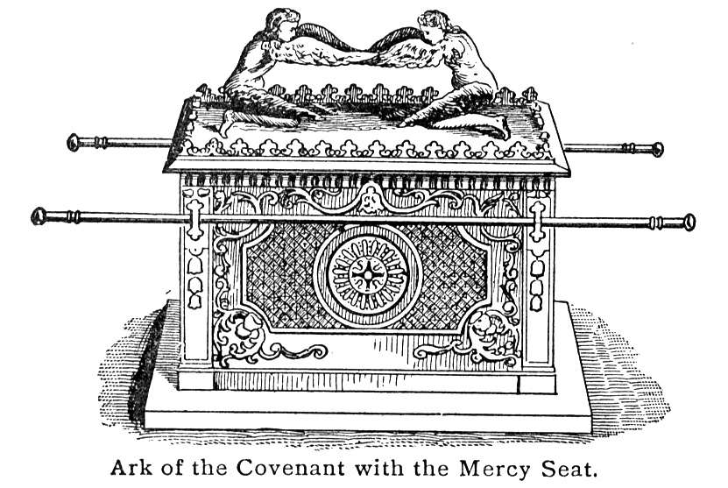
- 1 Kings 8:6-11: ⁶ The priests brought the ark of the Lord's covenant to its place in the Most Holy Room of the temple. They put it under the wings of the cherubim. ⁷ The cherubim's wings were spread out over the place where the ark was. They covered the ark. They also covered the poles that were used to carry it. ⁸ The poles were so long that their ends could be seen from the Holy Room in front of the Most Holy Room. But they couldn't be seen from outside the Holy Room. They are still there to this very day. ⁹ There wasn't anything in the ark except the two stone tablets. Moses had placed them in it at Mount Horeb. That's where the Lord had made a covenant with the Israelites. He made it after they came out of Egypt. ¹⁰ The priests left the Holy Room. Then the cloud filled the temple of the Lord. ¹¹ The priests couldn't do their work because of it. That's because the glory of the Lord filled his temple.
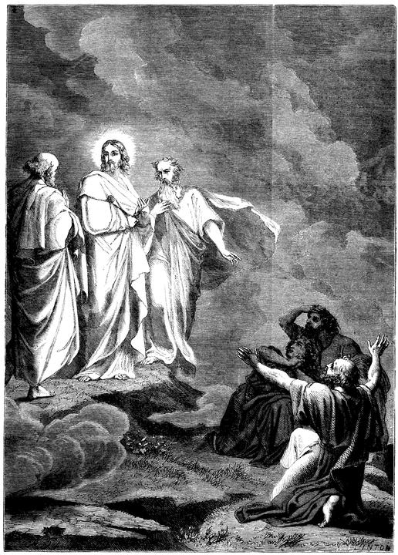
- Luke 9:28-36: Jesus' Appearance Is Changed ²⁸ About eight days after Jesus said this, he went up on a mountain to pray. He took Peter, John and James with him. ²⁹ As he was praying, the appearance of his face changed. His clothes became as bright as a flash of lightning. ³⁰ Two men, Moses and Elijah, ³¹ appeared in shining glory. Jesus and the two of them talked together. They spoke about his coming death. He was going to die soon in Jerusalem. ³² Peter and his companions had been very sleepy. But then they became completely awake. They saw Jesus' glory and the two men standing with him. ³³ As the men were leaving Jesus, Peter spoke up. "Master," he said to him, "it is good for us to be here. Let us put up three shelters. One will be for you, one for Moses, and one for Elijah." He didn't really know what he was saying. ³⁴ While Jesus was speaking, a cloud appeared. It surrounded them. The disciples were afraid as they entered the cloud. ³⁵ A voice came from the cloud. It said, "This is my Son, and I have chosen him. Listen to him." ³⁶ When the voice had spoken, they found that Jesus was alone. The disciples kept quiet about this. They didn't tell anyone at that time what they had seen.

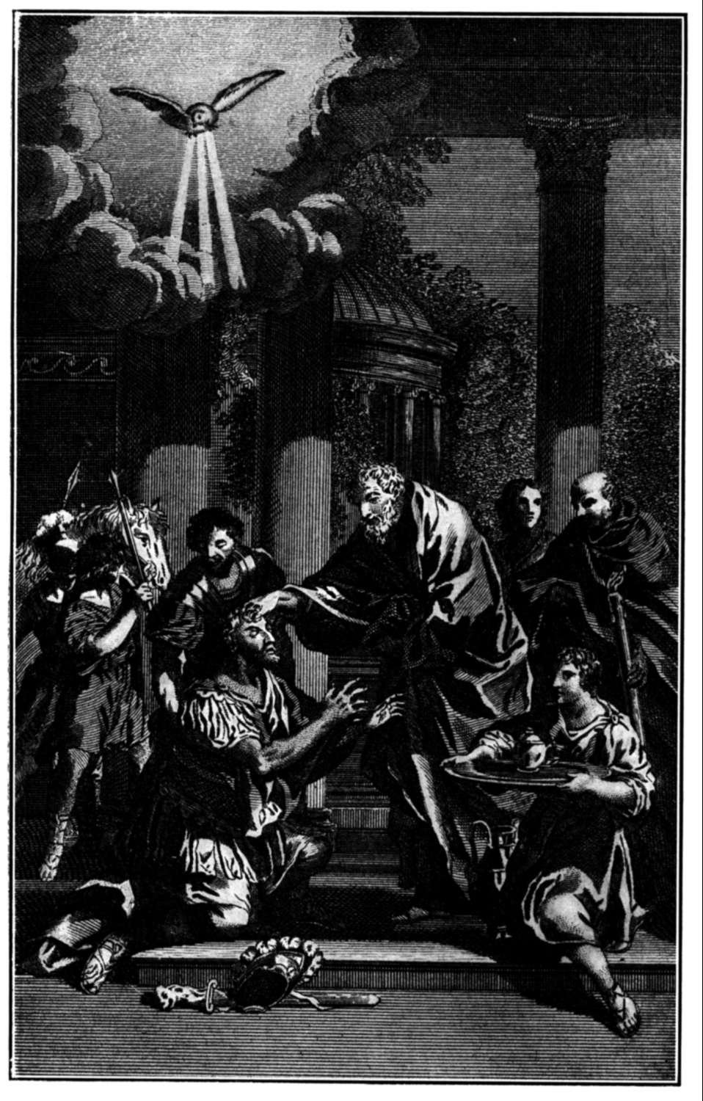
Acts 9:1-9: Saul Becomes a Believer: ¹ Meanwhile, Saul continued to oppose the Lord's followers. He said they would be put to death. He went to the high priest. ² He asked the priest for letters to the synagogues in Damascus. He wanted to find men and women who belonged to the Way of Jesus. The letters would allow him to take them as prisoners to Jerusalem. ³ On his journey, Saul approached Damascus. Suddenly a light from heaven flashed around him. ⁴ He fell to the ground. He heard a voice speak to him. "Saul! Saul!" the voice said. "Why are you opposing me?" ⁵ "Who are you, Lord?" Saul asked. "I am Jesus," he replied. "I am the one you are opposing. ⁶ Now get up and go into the city. There you will be told what you must do." ⁷ The men traveling with Saul stood there. They weren't able to speak. They had heard the sound. But they didn't see anyone. ⁸ Saul got up from the ground. He opened his eyes, but he couldn't see. So they led him by the hand into Damascus. ⁹ For three days he was blind. He didn't eat or drink anything.
- Revelation 21:22-27: ²²I didn't see a temple in the city. This was because the Lamb and the Lord God who rules over all are its temple. ²³ The city does not need the sun or moon to shine on it. God's glory is its light, and the Lamb is its lamp. ²⁴ The nations will walk by the light of the city. The kings of the world will bring their glory into it. ²⁵ Its gates will never be shut, because there will be no night there. ²⁶ The glory and honor of the nations will be brought into it. ²⁷ Only what is pure will enter it. No one who fools others or does shameful things will enter it. Only those whose names are written in the Lamb's Book of Life will enter the city.

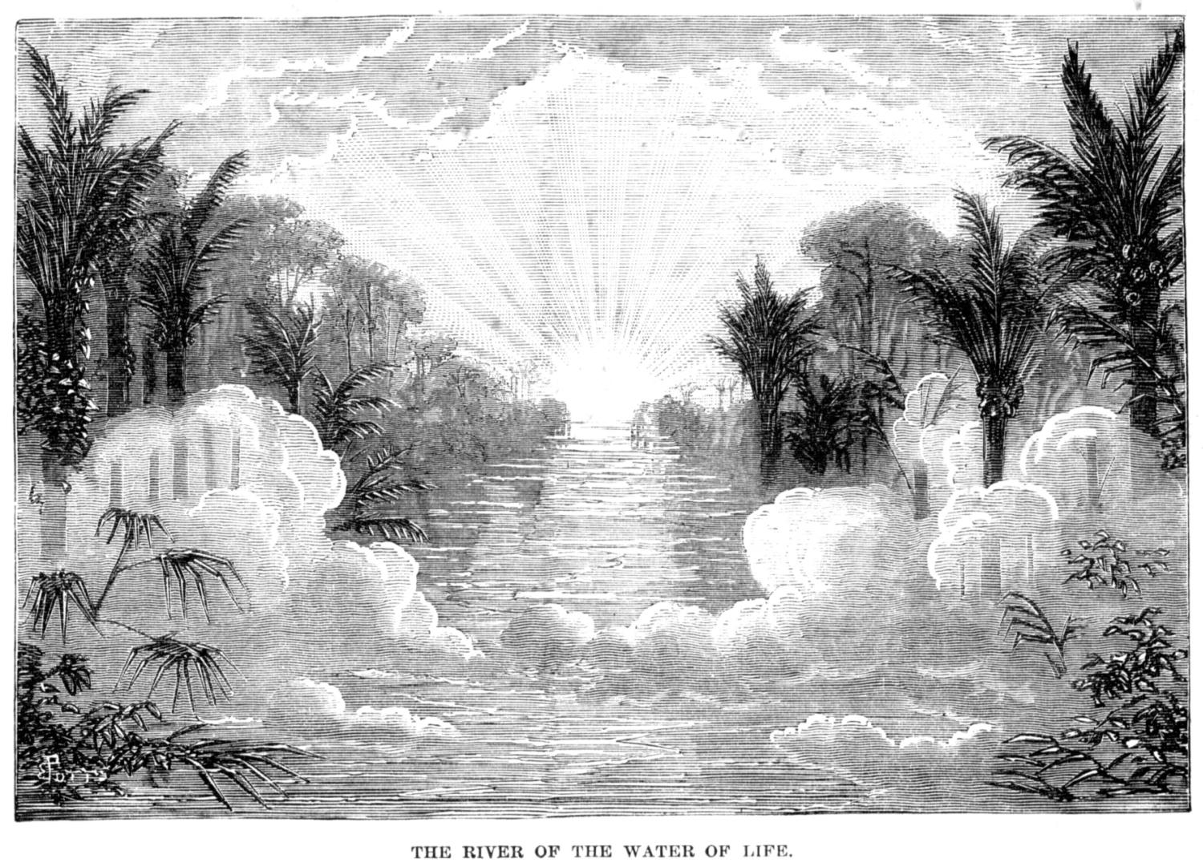
Revelation 22:1-5: The River of Life ¹ Then the angel showed me the river of the water of life. It was as clear as crystal. It flowed from the throne of God and of the Lamb. ² It flowed down the middle of the city's main street. On each side of the river stood the tree of life, bearing 12 crops of fruit. Its fruit was ripe every month. The leaves of the tree bring healing to the nations. ³ There will no longer be any curse. The throne of God and of the Lamb will be in the city. God's servants will serve him. ⁴ They will see his face. His name will be on their foreheads. ⁵ There will be no more night. They will not need the light of a lamp or the light of the sun. The Lord God will give them light. They will rule for ever and ever.

REVIEW THE READINGS:
- What phrase is common in each account?

- What makes this “radiance” or “shining” so intense?

DISCUSSION QUESTIONS:
- In Luke 9, what is the significance of this “shining quality” of Moses, Elijah and Jesus that Peter, James and John saw?

- What do these “radiance” readings indicate about heaven?

- What does this “radiance” quality tell us about God?

- When you think about the Old Testament nation of Israel and Jesus’ disciples what did they know and believe about heaven?

READ 2 Corinthians 4:3-6: ³ Suppose our good news is covered with a veil. Then it is veiled to those who are dying. ⁴ The god of this world has blinded the minds of those who don't believe. They can't see the light of the good news of Christ's glory. He is the likeness of God. ⁵ We do not preach about ourselves. We preach about Jesus Christ. We say that he is Lord. And we serve you because of him. ⁶ God said, "Let light shine out of darkness."—(Genesis 1:3) He made his light shine in our hearts. It shows us the light of God's glory in the face of Christ.
- What stands in the way of unbelievers receiving the message of forgiveness and salvation?

- What is “his light” in verse 6?

- What is meant by “God’s glory in the face of Christ?”

SUMMARY
- What did you learn about the nature of God in this lesson?

- What did you learn about God’s heaven?

- Why can you be sure that you will be in God’s heaven one day?

- Why do you not need to be afraid to stand in the presence of a holy, perfect and radiant God?

Scripture taken from the Holy Bible, NEW INTERNATIONAL READER'S VERSION®.Copyright © 1996, 1998 Biblica. All rights reserved throughout the world. Used by permission of Biblica.

Adapted from a Bible study originally prepared by Duane D. Anderson – 2010.

