PEOPLE OF THE BIBLE – ABRAHAM – MAN OF FAITH

PRAYER: Dear Lord, as you show me the faith of Abraham help me to live by faith, not by my own reason or insights. In Jesus’ name I ask it. Amen.

INTRODUCTION: What would you do if you were blindfolded and someone had to direct you down a mountain path with hairpin turns and steep drop offs? Would you want just anyone to lead you? Would you trust someone to lead you who had failed you in the past? Let us learn how Abraham trusted the LORD and how the LORD blessed him.


God Chooses Abraham - Read Genesis 12:1-9: ¹ The Lord had said to Abram, "Leave your country and your people. Leave your father's family. Go to the land I will show you. ² "I will make you into a great nation. I will bless you. I will make your name great. You will be a blessing to others. ³ I will bless those who bless you. I will put a curse on anyone who calls down a curse on you. All nations on earth will be blessed because of you." ⁴ So Abram left, just as the Lord had told him. Lot went with him. Abram was 75 years old when he left Haran. ⁵ He took his wife Sarai and his nephew Lot. They took all of the things they had gotten in Haran. They also took the workers they had gotten there. They set out for the land of Canaan. And they arrived there. ⁶ Abram traveled through the land. He went as far as the large tree of Moreh at Shechem. At that time the people of Canaan were living in the land. ⁷ The Lord appeared to Abram at Shechem. He said, "I will give this land to your children after you." So Abram built an altar there to honor the Lord, who had appeared to him.
⁸ From there, Abram went on toward the hills east of Bethel. He set up his tent there. Bethel was to the west, and Ai was to the east. Abram built an altar there and worshiped the Lord. ⁹ Then Abram left and continued toward the Negev Desert.
- What were the three orders God gave to Abraham in verse one?
  - .
  - .
  - .
- What is the three-fold covenant (agreement) that God made with Abraham in verses 2 & 3?
  - .
  - .
  - .
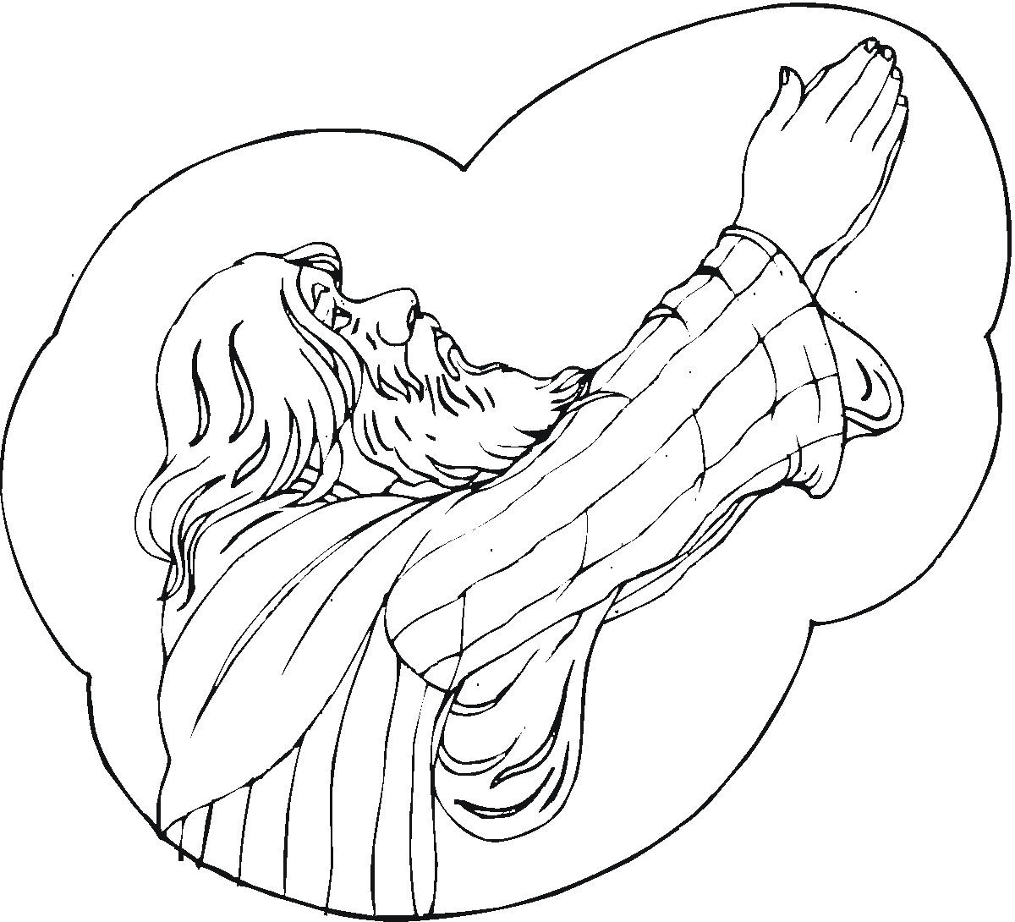
God Makes a Covenant with Abraham - Read Genesis 15:1-7: ¹ Some time later, Abram had a vision. The Lord said to him, "Abram, do not be afraid. I am like a shield to you. I am your very great reward." ² But Abram said, "Lord and King, what can you give me? I still don't have any children. My servant Eliezer comes from Damascus. When I die, he will get everything I own." ³ Abram continued, "You haven't given me any children. So a servant in my house will get everything I own." ⁴ Then a message came to Abram from the Lord. He said, "This man will not get what belongs to you. A son will come from your own body. He will get everything you own." ⁵ The Lord took Abram outside and said, "Look up at the sky. Count the stars, if you can." Then he said to him, "That is how many children you will have." ⁶ Abram believed the Lord. The Lord accepted Abram because he believed. So his faith made him right with the Lord. ⁷ He also said to Abram, "I am the Lord. I brought you out of Ur in Babylonia. I wanted to give you this land to take as your very own."
- What was missing in Abraham and Sarah’s marriage?

- What did Abraham suggest to God to solve his problem of no descendants?

Hagar and Ishmael - Read Genesis 16:1-15: ¹ Abram's wife Sarai had never had any children by him. But she had a female servant from Egypt named Hagar. ² So she said to Abram, "The Lord has kept me from having children. Go and make love to my servant. Maybe I can have a family through her." Abram agreed to what Sarai had said. ³ After he had been living in Canaan for ten years, his wife Sarai gave him her servant Hagar to be his wife. ⁴ He made love to Hagar. And she became pregnant. When Hagar knew she was pregnant, she began to look down on the woman who owned her. ⁵ Then Sarai said to Abram, "It's your fault that I'm suffering like this. I put my servant in your arms. Now that she knows she's pregnant, she looks down on me. May the Lord judge between you and me. May he decide which of us is right." ⁶ "Your servant belongs to you," Abram said. "Do with her what you think is best." Then Sarai treated Hagar badly. So Hagar ran away from her.
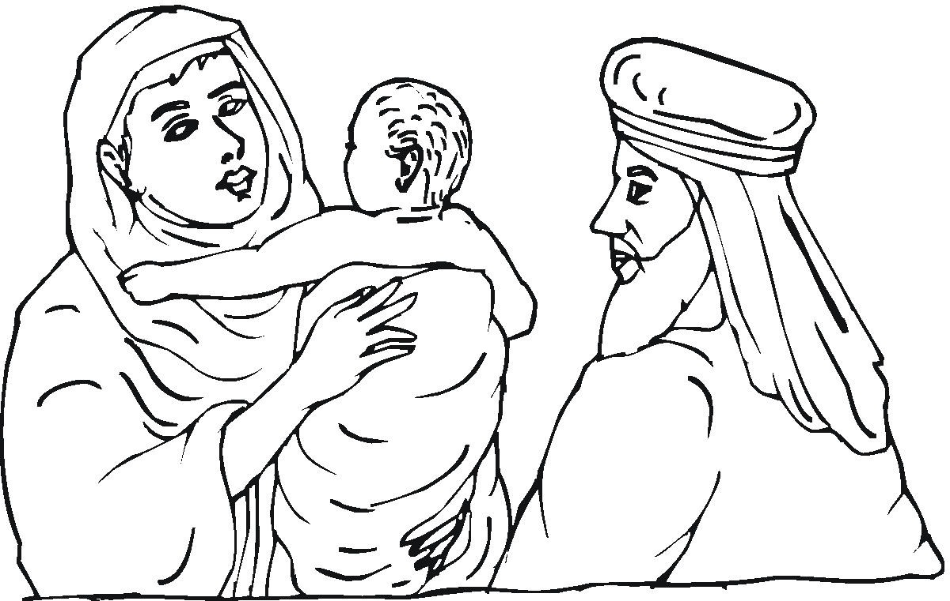
⁷ The angel of the Lord found Hagar near a spring of water in the desert. The spring was beside the road to Shur. ⁸ He said, "Hagar, you are the servant of Sarai. Where have you come from? Where are you going?" "I'm running away from my owner Sarai," she answered. ⁹ Then the angel of the Lord told her, "Go back to the woman who owns you. Obey her." ¹⁰ The angel continued, "I will greatly increase the number of your children after you. You will have more of them than anyone can count." ¹¹ The angel of the Lord also said to her, "You are now pregnant. You will have a son. You will name him Ishmael. That is because the Lord has heard about your suffering. ¹² He will be like a wild donkey. He will use his power against everyone. And everyone will be against him. He will not be friendly toward any of his relatives." ¹³ She gave a name to the Lord who spoke to her. She called him "You are the God who sees me." That's because she said, "I have now seen the One who sees me." ¹⁴ That's why the well was named Beer Lahai Roi. It's still there, between Kadesh and Bered. ¹⁵ So Hagar had a son by Abram. And Abram gave the name Ishmael to the son she had by him.

- What did Abraham and Sarah decide to do (on their own) in order to have a son?
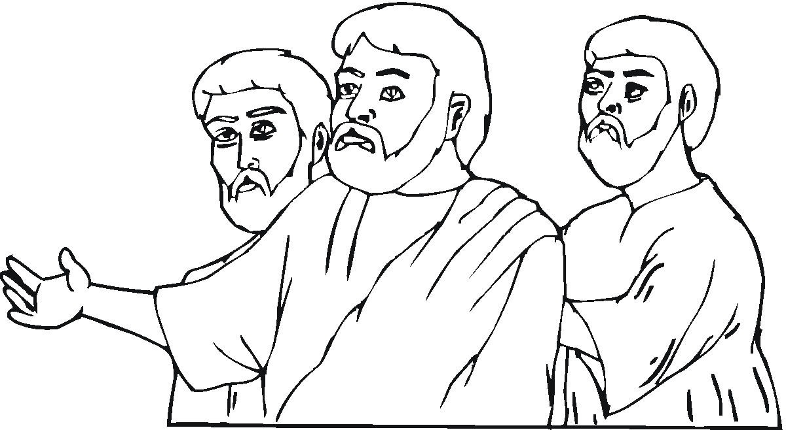
Three Men Visit Abraham – Read Genesis 18:1-15: ¹ The Lord appeared to Abraham near the large trees of Mamre. Abraham was sitting at the entrance to his tent. It was the hottest time of the day. ² Abraham looked up and saw three men standing nearby. He quickly left the entrance to his tent to meet them. He bowed low to the ground. ³ He said, "My lord, if you are pleased with me, don't pass me by. ⁴ Let a little water be brought. All of you can wash your feet and rest under this tree. ⁵ "Let me get you something to eat to give you strength. Then you can go on your way. I want to do this for you now that you have come to me." "All right," they answered. "Go ahead and do it." ⁶ So Abraham hurried into the tent to Sarah. "Quick!" he said. "Get about half a bushel of fine flour. Mix it and bake some bread." ⁷ Then he ran to the herd. He picked out a choice, tender calf. He gave it to a servant, who hurried to prepare it. ⁸ Then he brought some butter and milk and the calf that had been prepared. He served them to the three men. While they ate, he stood near them under a tree. ⁹ "Where is your wife Sarah?" they asked him. "Over there, in the tent," he said. ¹⁰ Then the Lord said, "You can be sure that I will return to you about this time next year. Your wife Sarah will have a son." Sarah was listening at the entrance to the tent behind him. ¹¹ Abraham and Sarah were already very old. Sarah was too old to have a baby. ¹² So she laughed to herself. She thought, "I'm worn out, and my husband is old. Can I really know the joy of having a baby?" ¹³ Then the Lord said to Abraham, "Why did Sarah laugh? Why did she say, 'Will I really have a baby, now that I am old?' ¹⁴ Is anything too hard for me? I will return to you at the appointed time next year. Sarah will have a son." ¹⁵ Sarah was afraid. So she lied and said, "I didn't laugh." But the Lord said, "Yes, you did."
- Who were these three men who appeared to Abraham and Sarah?

- Why did Sarah laugh at the message of these three men?

Isaac is Born – Read Genesis 21:1-5: ¹ The Lord was gracious to Sarah, just as he had said he would be. He did for Sarah what he had promised to do. ² Sarah became pregnant. She had a son by Abraham when he was old. He was born at the exact time God had promised him. ³ Abraham gave the name Isaac to the son Sarah had by him. ⁴ When his son Isaac was eight days old, Abraham circumcised him. He did it exactly as God had commanded him. ⁵ Abraham was 100 years old when his son Isaac was born to him.
- What does this account prove to you as a Christian today?

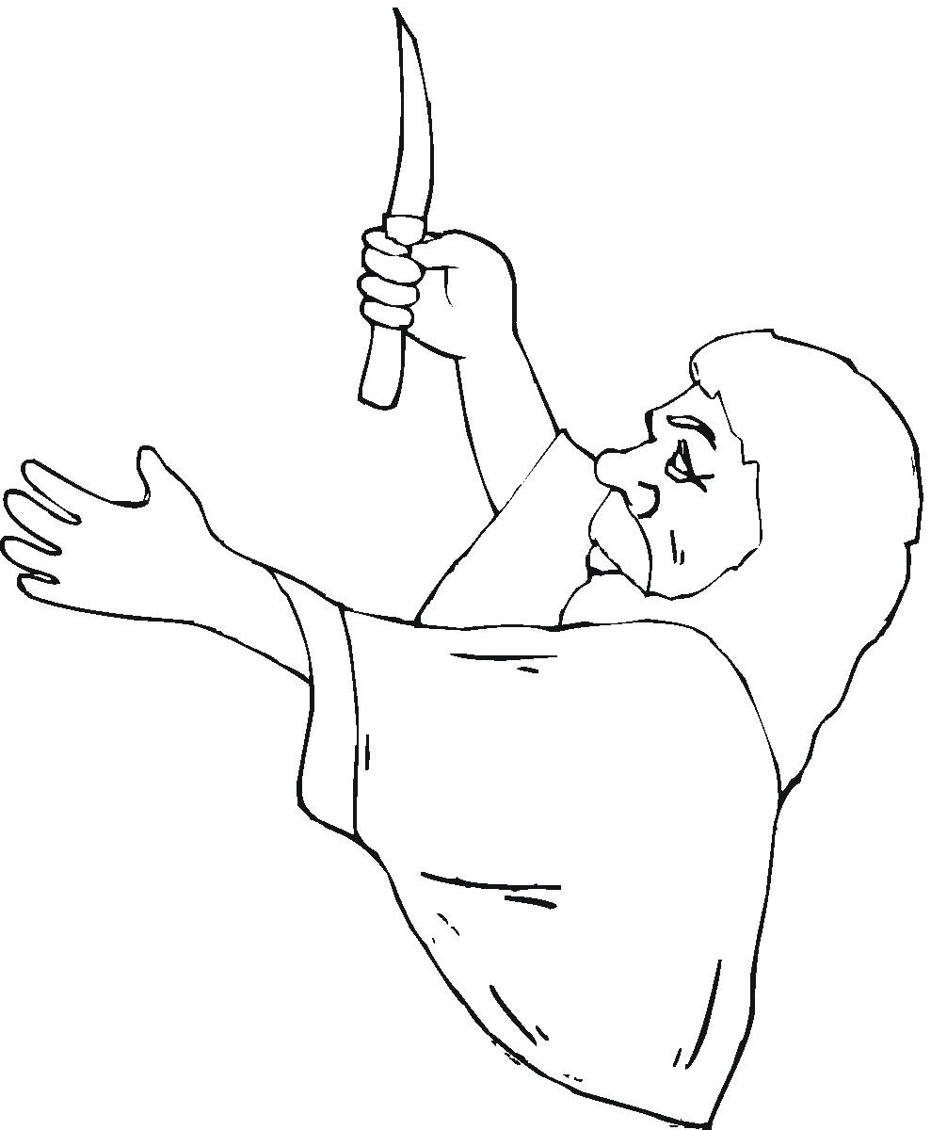
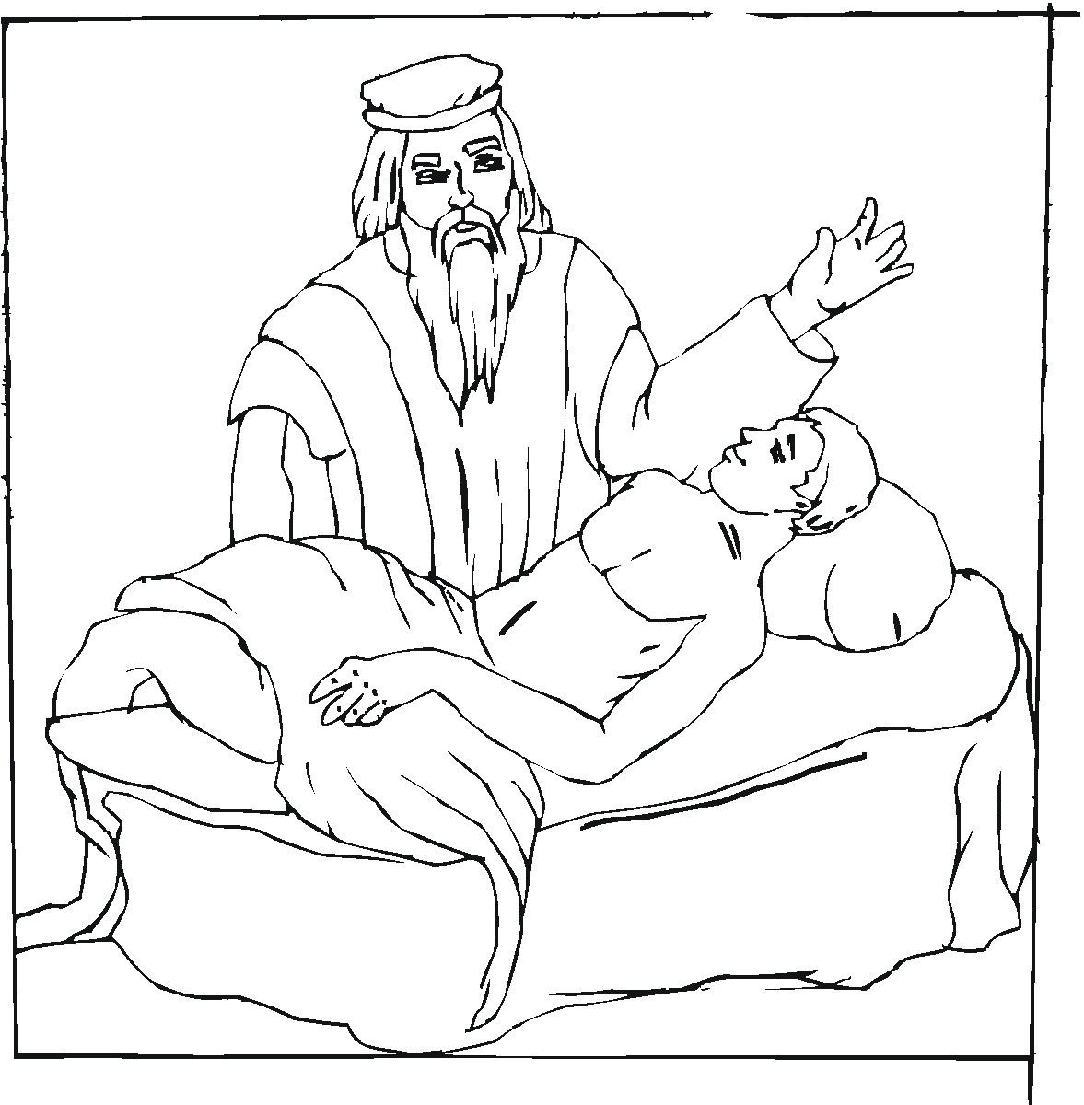
God Puts Abraham to the Test – Read Genesis 22:1-19: ¹ Some time later God put Abraham to the test. He said to him, "Abraham!" "Here I am," Abraham replied. ² Then God said, "Take your son, your only son. He is the one you love. Take Isaac. Go to Moriah. Give him to me there as a burnt offering. Sacrifice him on one of the mountains I will tell you about." ³ Early the next morning Abraham got up. He put a saddle on his donkey. He took two of his servants and his son Isaac with him. He cut enough wood for the burnt offering. Then he started out for the place God had told him about. ⁴ On the third day Abraham looked up. He saw the place a long way off. ⁵ He said to his servants, "Stay here with the donkey. The boy and I will go over there and worship. Then we'll come back to you." ⁶ Abraham put the wood for the burnt offering on his son Isaac. He himself carried the fire and the knife. The two of them walked on together. ⁷ Then Isaac spoke up. He said to his father Abraham, "Father?" "Yes, my son?" Abraham replied. "The fire and wood are here," Isaac said. "But where is the lamb for the burnt offering?" ⁸ Abraham answered, "God himself will provide the lamb for the burnt offering, my son." The two of them walked on together. ⁹ They reached the place God had told Abraham about. There Abraham built an altar. He arranged the wood on it. He tied up his son Isaac. He placed him on the altar, on top of the wood. ¹⁰ Then he reached out his hand. He took the knife to kill his son. ¹¹ But the angel of the Lord called out to him from heaven. He said, "Abraham! Abraham!" "Here I am," Abraham replied. ¹² "Do not lay a hand on the boy," he said. "Do not do anything to him. Now I know that you have respect for God. You have not held back from me your son, your only son." ¹³ Abraham looked up. There in a bush he saw a ram. It was caught by its horns. He went over and took the ram. He sacrificed it as a burnt offering instead of his son. ¹⁴ So Abraham named that place The Lord Will Provide. To this day people say, "It will be provided on the mountain of the Lord." ¹⁵ The angel of the Lord called out to Abraham from heaven a second time. ¹⁶ He said, "I am taking an oath in my own name. I will bless you because of what you have done," announces the Lord. "You have not held back your son, your only son. ¹⁷ "So I will certainly bless you. I will make your children after you as many as the stars in the sky. I will make them as many as the grains of sand on the seashore. Your children will take over the cities of their enemies. ¹⁸ All nations on earth will be blessed because of your children. All of that will happen because you have obeyed me." ¹⁹ Then Abraham returned to his servants. They started out together for Beersheba. And Abraham stayed in Beersheba.
- Why was the order that God gave to Abraham so difficult for him to understand and carry out?

- What can you learn from this account?

- Why can this account be considered a “double feature,” or a double image of Jesus’ work on earth?

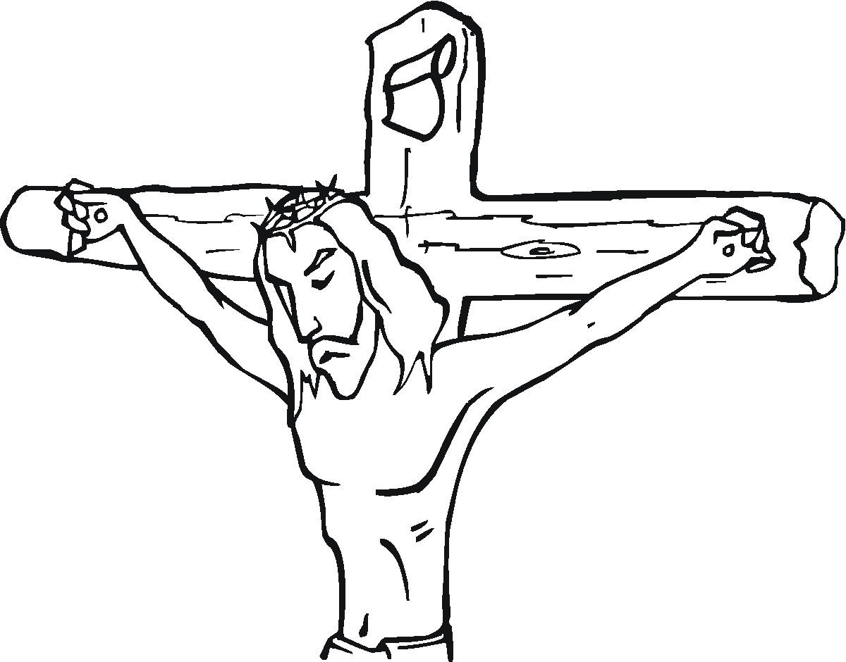
  - Isaac, Abraham’s only son was prepared for sacrifice…
  - A ram was substituted for Isaac at the last minute by God …
  - Why is Abraham known as a man of great faith?


Abraham – A Hero of Faith - Read Hebrews 11:8-19: ⁸ Abraham had faith. So he obeyed God. God called him to go to a place he would later receive as his own. So he went. He did it even though he didn't know where he was going. ⁹ Because of his faith he made his home in the land God had promised him. He was like an outsider in a strange country. He lived there in tents. So did Isaac and Jacob. They received the same promise he did. ¹⁰ Abraham was looking forward to the city that has foundations. He was waiting for the city that God planned and built. ¹¹ Abraham had faith. So God made it possible for him to become a father. He became a father even though he was too old. Sarah also was too old to have children. But Abraham believed that the One who made the promise was faithful. ¹² Abraham was past the time when he could have children. But many children came from that one man. They were as many as the stars in the sky. They were as many as the sand on the seashore. No one could count them. ¹³ All those people were still living by faith when they died. They didn't receive the things God had promised. They only saw them and welcomed them from a long way off. They openly said that they were outsiders and strangers on earth. ¹⁴ People who say things like that show that they are looking for a country of their own. ¹⁵ What if they had been thinking of the country they had left? Then they could have returned to it. ¹⁶ Instead, they longed for a better country. They wanted one in heaven. So God is pleased when they call him their God. In fact, he has prepared a city for them. ¹⁷ Abraham had faith. So he offered Isaac as a sacrifice. That happened when God put him to the test. Abraham had received the promises. But he was about to offer his one and only son. ¹⁸ God had said to him, "Your family line will continue through Isaac."—(Genesis 21:12) Even so, Abraham was going to offer him up. ¹⁹ Abraham believed that God could raise the dead. In a way, he did receive Isaac back from death.

- Why did Abraham obey God’s call, even though he did not know where God was sending him?

- How was Abraham willing to sacrifice his only son, knowing that the future of the nation of Israel depended on Isaac’s children?

- Even though Abraham never knew Jesus, how was he saved?

- How are you saved?

- How do you compare your faith with that of Abraham?

Closing Prayer
Faith is a living power from heaven
That grasps the promise God has given,
A trust that cannot be overthrown,
Fixed heartily on Christ alone.
(Christian Worship 404, verse 1)

Scripture taken from the Holy Bible, NEW INTERNATIONAL READER'S VERSION®.Copyright © 1996, 1998 Biblica. All rights reserved throughout the world. Used by permission of Biblica.

Adapted from a Bible study originally prepared by Duane Anderson (no date).

