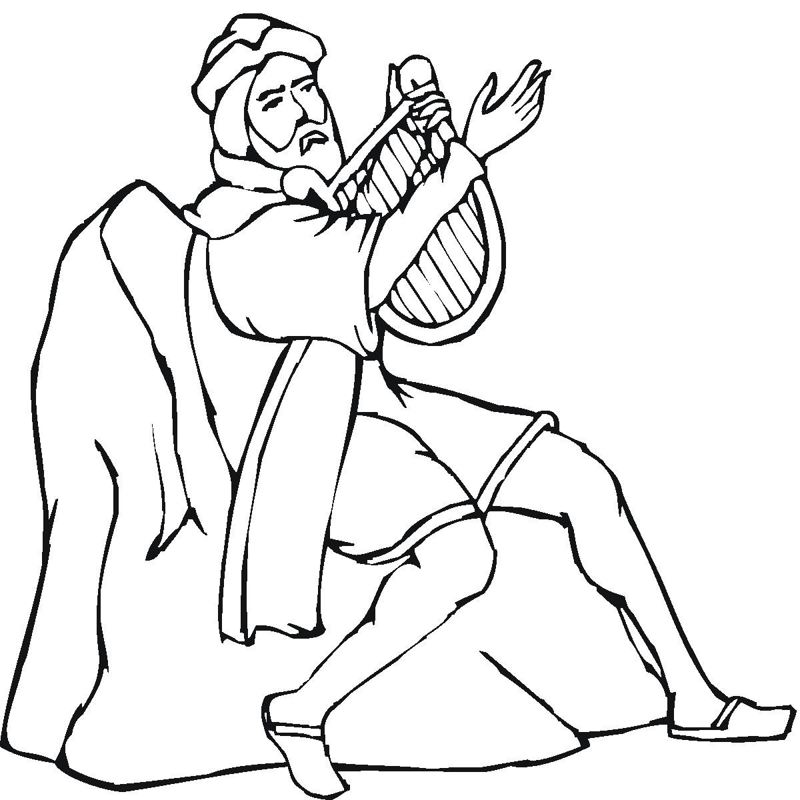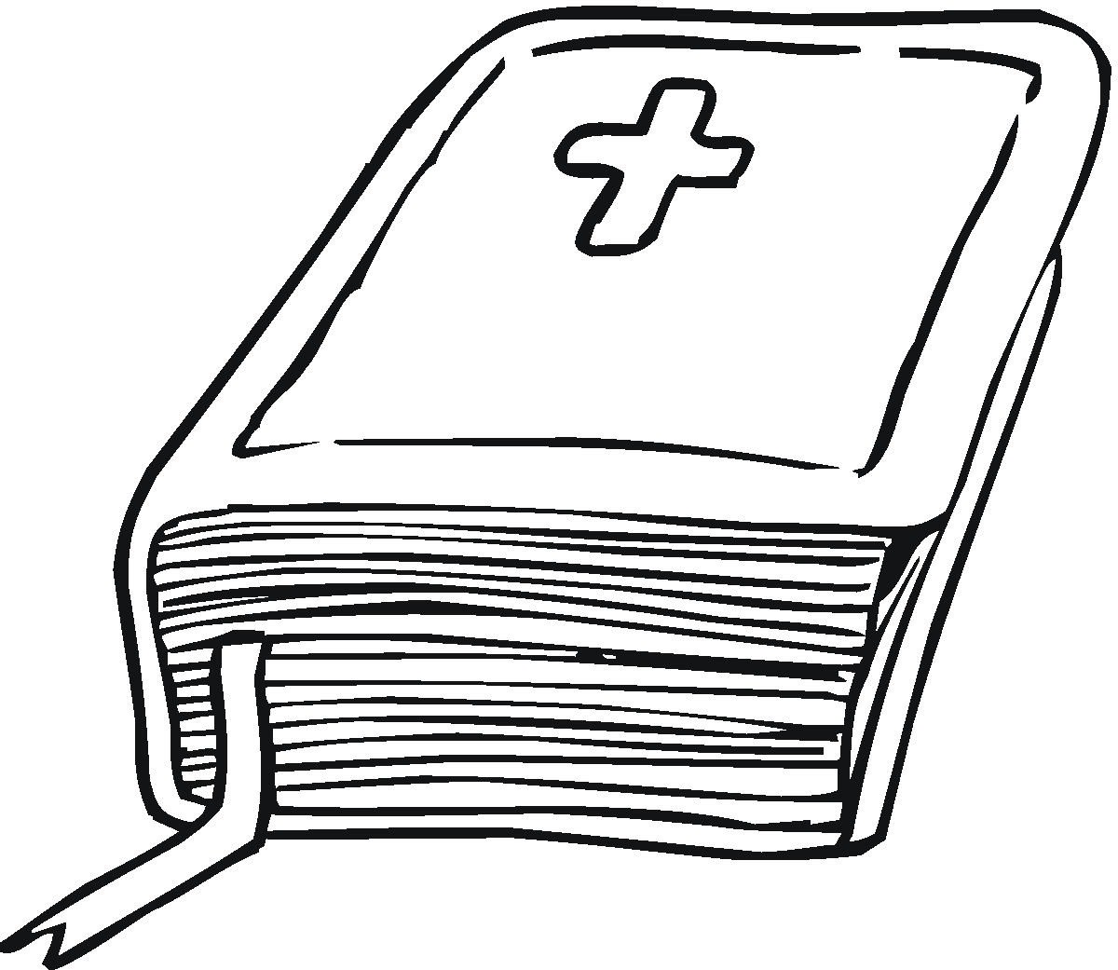
GOD SPEAKS TO ME ABOUT CREATION
A Bible Study on the Basis of Psalm 104

AIM: Let us become more aware of the beauty around us and thank God for his work of creation. Let us enjoy happier living as we see how our God takes care of us every day.

PRAYER: Dear Lord, when we look around us we often miss the beauty of your creation because our eyes are blinded with our own problems. Help us to set aside those problems for a few moments today and reflect on all you have done for us and our salvation. In Jesus’ name we ask it. Amen.

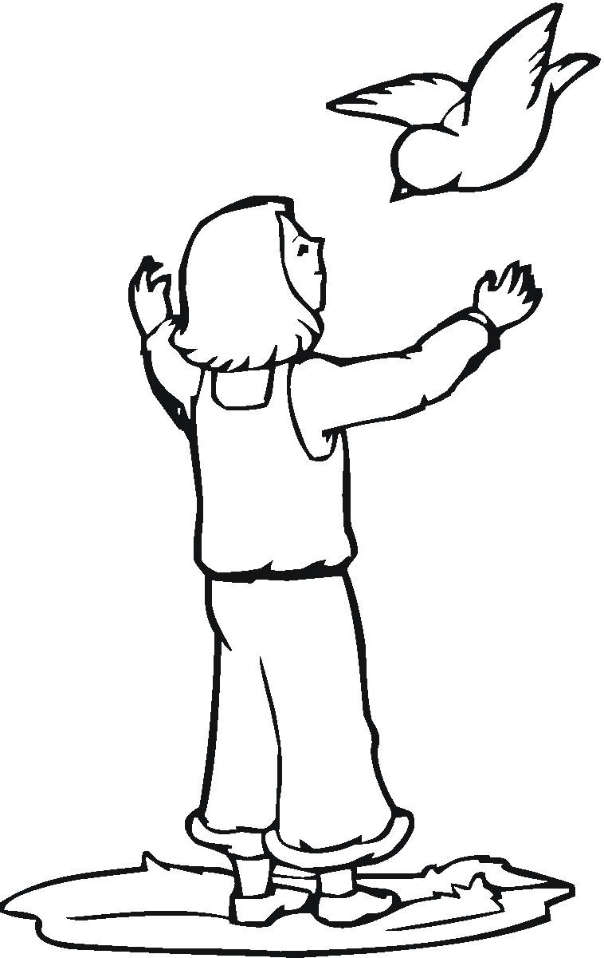
INTRODUCTION (v. 1): When we study creation we usually go to Genesis 1-2 and rightfully so. However, there are many other places in Scripture that reveal how God created the heavens and the earth. This psalm is one of them. We will want to see not only the original acts of creation, but how our God still uses his created things to provide for us and bless us.

- ¹ I will praise the Lord. Lord my God, you are very great. You are dressed in glory and majesty.
  - 1. What does it mean to “praise” the Lord?

DAY ONE – LIGHT (v. 2a)
- ² You wrap yourself in light as if it were a robe.
  - 2. Where did the light the psalmist talks about come from?

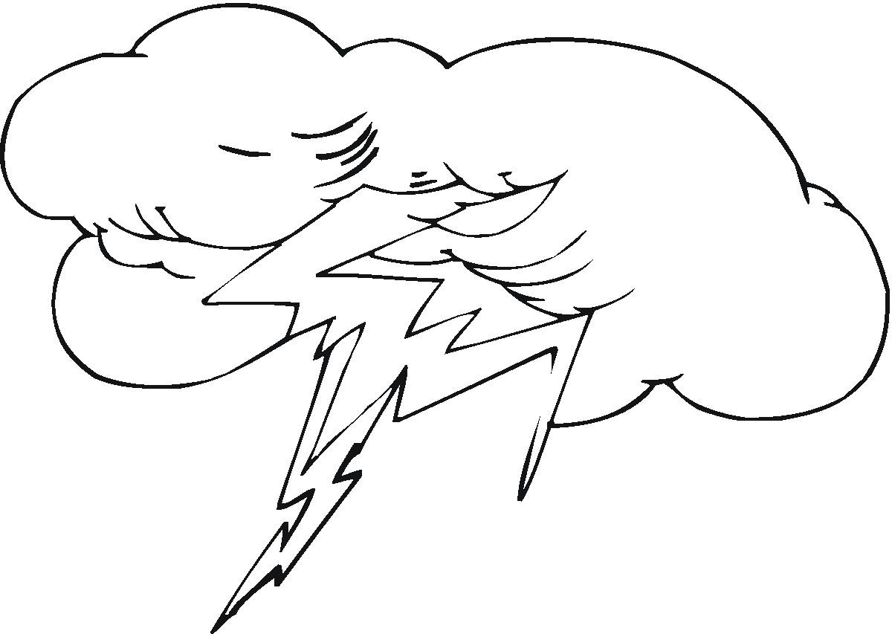
DAY TWO – THE SKY (vv. 2b – 4)
- You spread the heavens out like a tent. ³ You build your palace high in the heavens. You make the clouds serve as your chariot. You ride on the wings of the wind. ⁴ You make the winds serve as your messengers. You make flashes of lightning serve you.
  - 3. Why does the Lord use pictures like “tent…palace…chariot” and “wings?”

DAY THREE – THE WATERS AND PLANTS (vv. 5-18)
- ⁵ You placed the earth on its foundations. It can never be moved. ⁶ You covered it with the oceans like a blanket. The waters covered the mountains. ⁷ But you commanded the waters, and they ran away. At the sound of your thunder they rushed off. ⁸ They flowed down the mountains. They went into the valleys. They went to the place you appointed for them. ⁹ You drew a line they can't cross. They will never cover the earth again. ¹⁰ You make springs pour water into the valleys. It flows between the mountains. ¹¹ The springs give water to all of the wild animals. The wild donkeys satisfy their thirst. ¹² The birds of the air build nests by the waters. They sing among the branches. ¹³ You water the mountains from your palace high in the clouds. The earth is filled with the things you have made. ¹⁴ You make grass grow for the cattle and plants for people to take care of. That's how they get food from the earth. ¹⁵ There is wine to make people glad. There is olive oil to make them healthy. And there is bread to make them strong. ¹⁶ The cedar trees of Lebanon belong to the Lord. You planted them and gave them plenty of water. ¹⁷ There the birds make their nests. The stork has its home in the pine trees. ¹⁸ The high mountains belong to the wild goats. The cliffs are a safe place for the rock badgers.

  - 4. How are we to understand the poetry used here with the facts of creation in Genesis 1 & 2?

  - 5. What is the significance of the “wine…olive oil” and “bread” in verse 15?

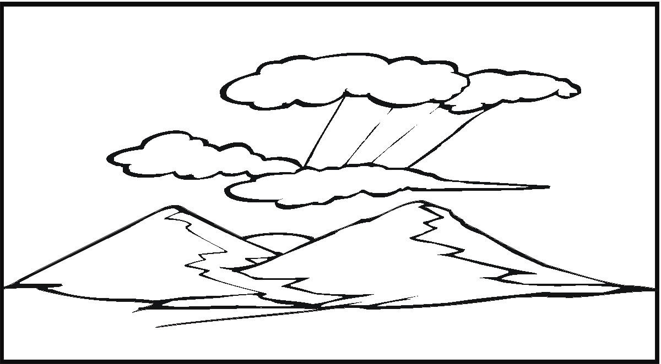
DAY FOUR (vv. 19-23)
- ¹⁹ The moon serves to mark off the seasons. The sun knows when to go down. ²⁰ You bring darkness, and it becomes night. Then all the animals of the forest prowl around. ²¹ The lions roar while they hunt. All of their food comes from God. ²² The sun rises, and they slip away. They return to their dens and lie down. ²³ Then a man gets up and goes to work. He keeps working until evening.
  - 6. How do both day and night serve for our good?

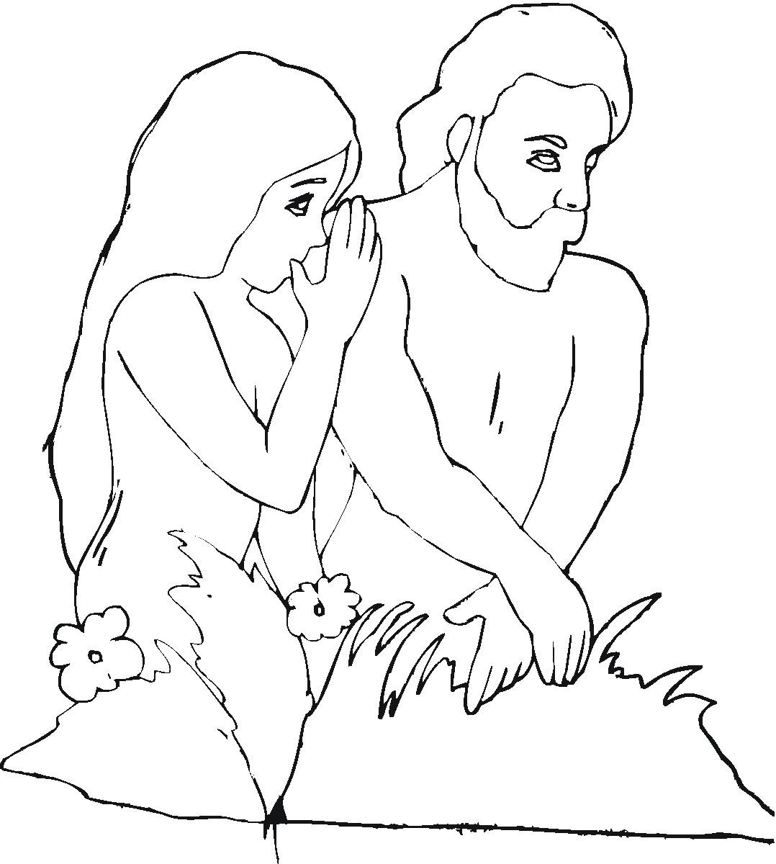
DAYS FIVE AND SIX – ANIMALS AND MAN (vv. 24-30)
- ²⁴ Lord, you have made so many things! How wise you were when you made all of them! The earth is full of your creatures. ²⁵ Look at the ocean, so big and wide! It is filled with more creatures than people can count. It is filled with living things, from the largest to the smallest. ²⁶ Ships sail back and forth on it. The leviathan, the sea monster you made, plays in it. ²⁷ All of those creatures depend on you to give them their food when they need it. ²⁸ When you give it to them, they eat it. When you open your hand, they are satisfied with good things. ²⁹ When you turn your face away from them, they are terrified. When you take away their breath, they die and turn back into dust. ³⁰ When you send your Spirit, you create them. You give new life to the earth.
  - 7. If we have to work to get the food we need why should we thank God for it?

CLOSING BENEDICTION AND PRAYER (vv. 31-35)
- ³¹ May the glory of the Lord continue forever. May the Lord be happy with what he has made. ³² When he looks at the earth, it trembles. When he touches the mountains, they pour out smoke. ³³ I will sing to the Lord all my life. I will sing praise to my God as long as I live. ³⁴ May these thoughts of mine please him. I find my joy in the Lord. ³⁵ But may those who sin be gone from the earth. May evil people disappear. I will praise the Lord. Praise the Lord.
  - 8. What should move you to thank and praise God after studying this psalm?

  - 9. Of all of the blessings God has given us what is the most important blessing?

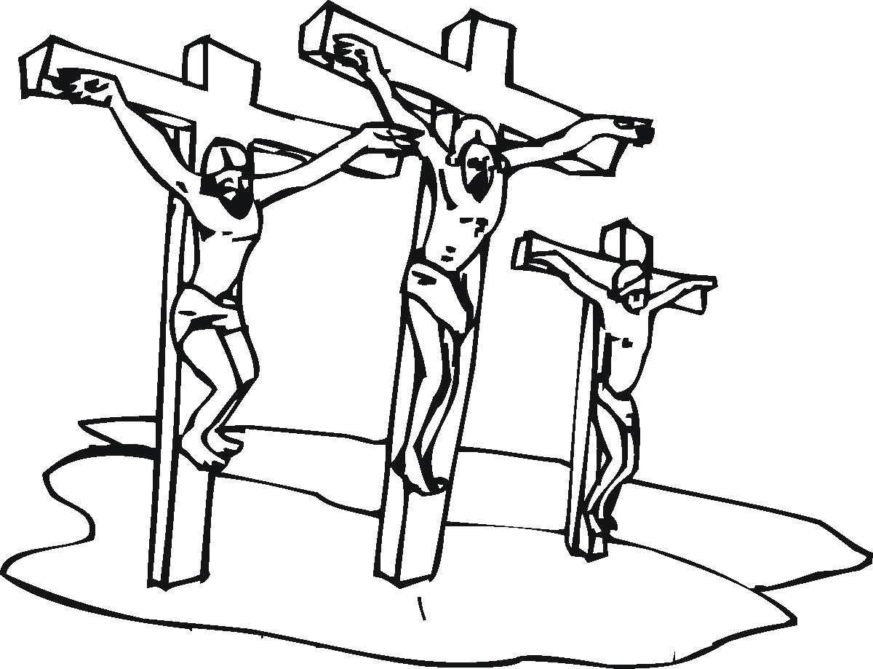

Scripture taken from the Holy Bible, NEW INTERNATIONAL READER'S VERSION®.Copyright © 1996, 1998 International Bible Society. All rights reserved throughout the world. Used by permission of International Bible Society.

Material adapted from “God Speaks to Me in the Psalms” by Carla Holtermann, Concordia Publishing House (ND) and “A Commentary of Psalms 1-72,” by John Brug, Northwestern Publishing House, 2004.

