
JUST WHO IS THIS JESUS CHRIST?

Opening Prayer: Thank you, Lord, for listening to me and answering my questions. Help me today to better understand who you are and what you have done for me. Above all, O Lord, send your Holy Spirit that I might believe the truths you are revealing to me and that one day I might be in heaven with you. In Jesus’ name I ask it. Amen.

Background: As you read history books, books on philosophy and/or books about the major religious movements of the world, you receive a range of insights about Jesus Christ. Perhaps you might remember what your parents or a favorite teacher told you about Jesus.

What do people say about Jesus? Was he a famous prophet, a Jewish historical figure, or one of the most kindly, revered persons who ever lived on earth? Was his key contribution the founding of a new religious movement? Why is Jesus still so vital, so central to contemporary life today?

What does the Bible say about Jesus?

Read John 1:41: The first thing Andrew did was to find his brother Simon. He told him, "We have found the Messiah." Messiah means Christ.

Read John 4:25-26: 25 The woman said, "I know that Messiah is coming." (He is called Christ.) "When he comes, he will explain everything to us."26 Then Jesus said, "I, the one speaking to you, am he."

Read Matthew 16:13-16: 13 Jesus went to the area of Caesarea Philippi. There he asked his disciples, "Who do people say the Son of Man is?" 14 They replied, "Some say John the Baptist. Others say Elijah. Still others say Jeremiah, or one of the prophets." 15 "But what about you?" he asked. "Who do you say I am?" 16 Simon Peter answered, "You are the Christ. You are the Son of the living God."

Read Luke 4:18: (Jesus:) “The Spirit of the Lord is on me. He has anointed me to tell the good news to poor people. He has sent me to announce freedom for prisoners. He has sent me so that the blind will see again. He wants me to free those who are beaten down.” (Note: The word “Christ” is the Greek word “the anointed one.”)

Read Luke 9:18-26: 18 One day Jesus was praying alone. Only his disciples were with him. He asked them, "Who do the crowds say I am?" 19 They replied, "Some say John the Baptist. Others say Elijah. Still others say that one of the prophets of long ago has come back to life." 20 "But what about you?" he asked. "Who do you say I am?" Peter answered, "The Christ of God." 21 Jesus strongly warned them not to tell this to anyone. 22 He said, "The Son of Man must suffer many things. The elders will not accept him. The chief priests and teachers of the law will not accept him either. He must be killed and on the third day rise from the dead." 23 Then he said to all of them, "If anyone wants to follow me, he must say no to himself. He must pick up his cross every day and follow me. 24 If he wants to save his life, he will lose it. But if he loses his life for me, he will save it. 25 What good is it if someone gains the whole world but loses or gives up his very self? 26 "Suppose you are ashamed of me and my words. The Son of Man will come in his glory and in the glory of the Father and the holy angels. Then he will be ashamed of you.

- What is the meaning of the word “Messiah?”

- What is the common thread between the Old Testament and the New Testament?

- What are the more conservative practicing Jewish people still waiting for today?


Advent: The coming of Jesus to earth at Christmas as a baby is called Jesus’ advent. The word “advent” means “coming” or “arrival.” In some churches the Advent season – four weeks before Christmas - marks the beginning of the Christian church year (rather than January 1).

Read Matthew 14:1-2: 1 At that time Herod, the ruler of Galilee and Perea, heard reports about Jesus. 2 He said to his attendants, "This is John the Baptist. He has risen from the dead! That is why he has the power to do miracles."

Read Luke 7:19: He sent them to the Lord. They were to ask Jesus, "Are you the one who was supposed to come? Or should we look for someone else?"

Read John 7:12-13, 40-42: 12 Many people in the crowd were whispering about him. Some said, "He is a good man." Others replied, "No. He fools the people." 13 But no one would say anything about him openly. They were afraid of the Jews... 40 When some of the people heard his words, they said, "This man must be the Prophet we've been expecting." 41 Others said, "He is the Christ. "Still others asked, "How can the Christ come from Galilee? 42 Doesn't Scripture say that the Christ will come from David's family? Doesn't it say that he will come from Bethlehem, the town where David lived?"

- Why do you think Jesus was so concerned that his disciples understand who he was and what the purpose of his life was to be?

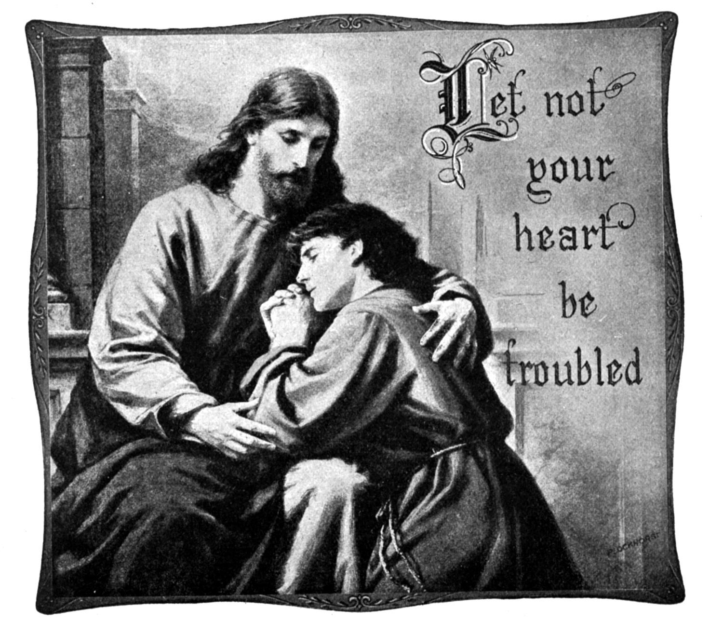

- Explain in your own words what Jesus means to you?

Jesus’ purpose in coming to earth. If Jesus came to earth as the long-promised Messiah, then why did most of the people at Jesus’ time misunderstand him? Only if a person could live a perfect life, could he offer his life as a substitute for another person.

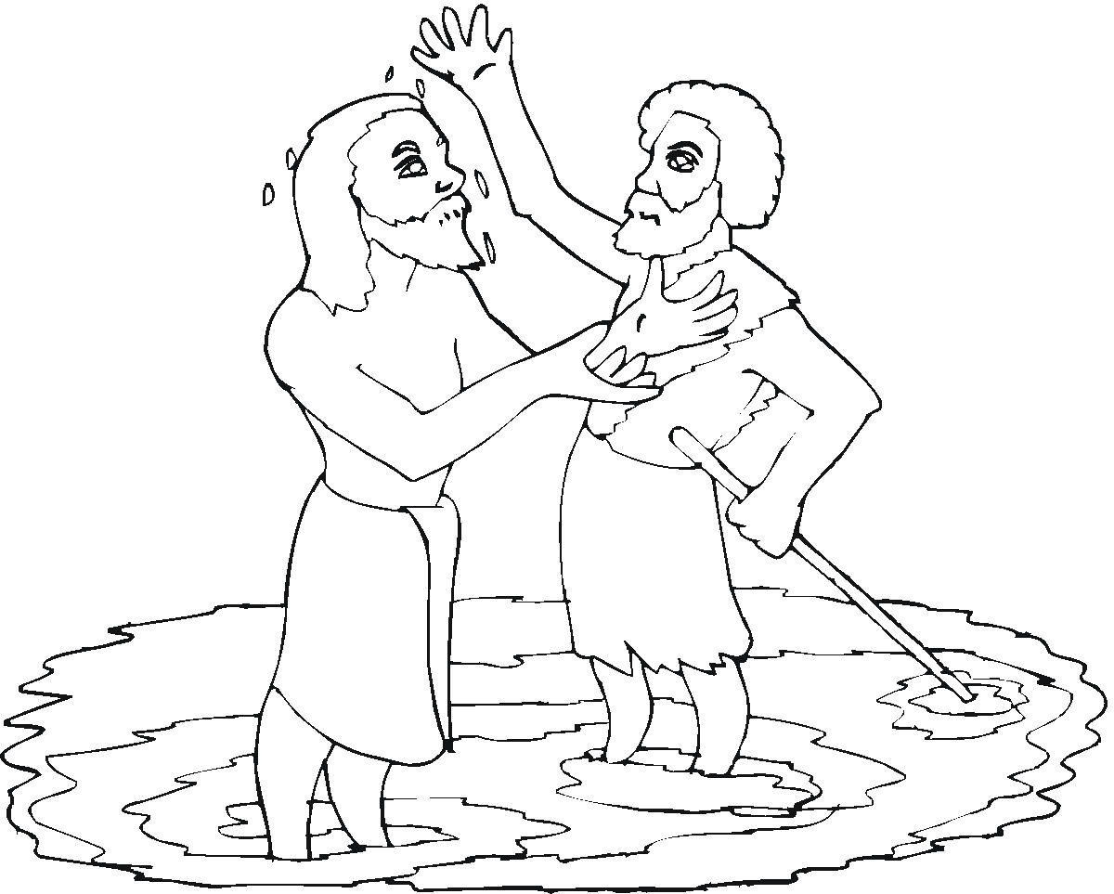
Read John 1:29-34: 29 The next day John saw Jesus coming toward him. John said, "Look! The Lamb of God! He takes away the sin of the world! 30 This is the One I was talking about. I said, 'A man who comes after me is more important than I am. That's because he existed before I was born.' 31 I did not know him. But God wants to make it clear to Israel who this person is. That's the reason I came baptizing with water." 32 Then John told them, "I saw the Holy Spirit come down from heaven like a dove. The Spirit remained on Jesus. 33 I would not have known him. But the One who sent me to baptize with water told me, 'You will see the Spirit come down and remain on someone. He is the One who will baptize with the Holy Spirit.' 34 I have seen it happen. I give witness that this is the Son of God."

Read Mark 10:45: Even the Son of Man did not come to be served. Instead, he came to serve others. He came to give his life as the price for setting many people free."

Read Hebrews 4:14-15: 14 We have a great high priest. He has gone up into the heavens. He is Jesus the Son of God. So let us hold firmly to what we say we believe. 15 We have a high priest who can feel it when we are weak and hurting. We have a high priest who has been tempted in every way, just as we are. But he did not sin.

Read Romans 5:18-19: 18 One man's sin brought guilt to all people. So also one right act made all people right with God. And all who are right with God will live. 19 Many people were made sinners because one man did not obey. But one man did obey. That is why many people will be made right with God.

- Why did Jesus have to be God in order to offer his life for all people of all times?

Read the Great Commission – Matthew 28:18-20: 18 Then Jesus came to them. He said, "All authority in heaven and on earth has been given to me. 19 So you must go and make disciples of all nations. Baptize them in the name of the Father and of the Son and of the Holy Spirit. 20 Teach them to obey everything I have commanded you. And you can be sure that I am always with you, to the very end."

- What does it mean for the world when the Bible teaches that Jesus lived a perfect life and died a complete, all-atoning death?

- What is the significance of this message for the world today?

9. What is the significance of this message for you personally?

The Bible teaches that Judgment Day will happen only after the entire world has had an opportunity to hear the gospel message.

Read Isaiah 55:10-11: 10 The rain and the snow come down from the sky. They do not return to it without watering the earth. They make plants come up and grow. The plants produce seeds for farmers. They also produce food for people to eat. 11 The words I speak are like that. They will not return to me without producing results. They will accomplish what I want them to. They will do exactly what I sent them to do.

Read John 10:16: "I have other sheep that do not belong to this sheep pen. I must bring them in too. They also will listen to my voice. Then there will be one flock and one shepherd.

- Why hasn’t Judgment Day occurred?
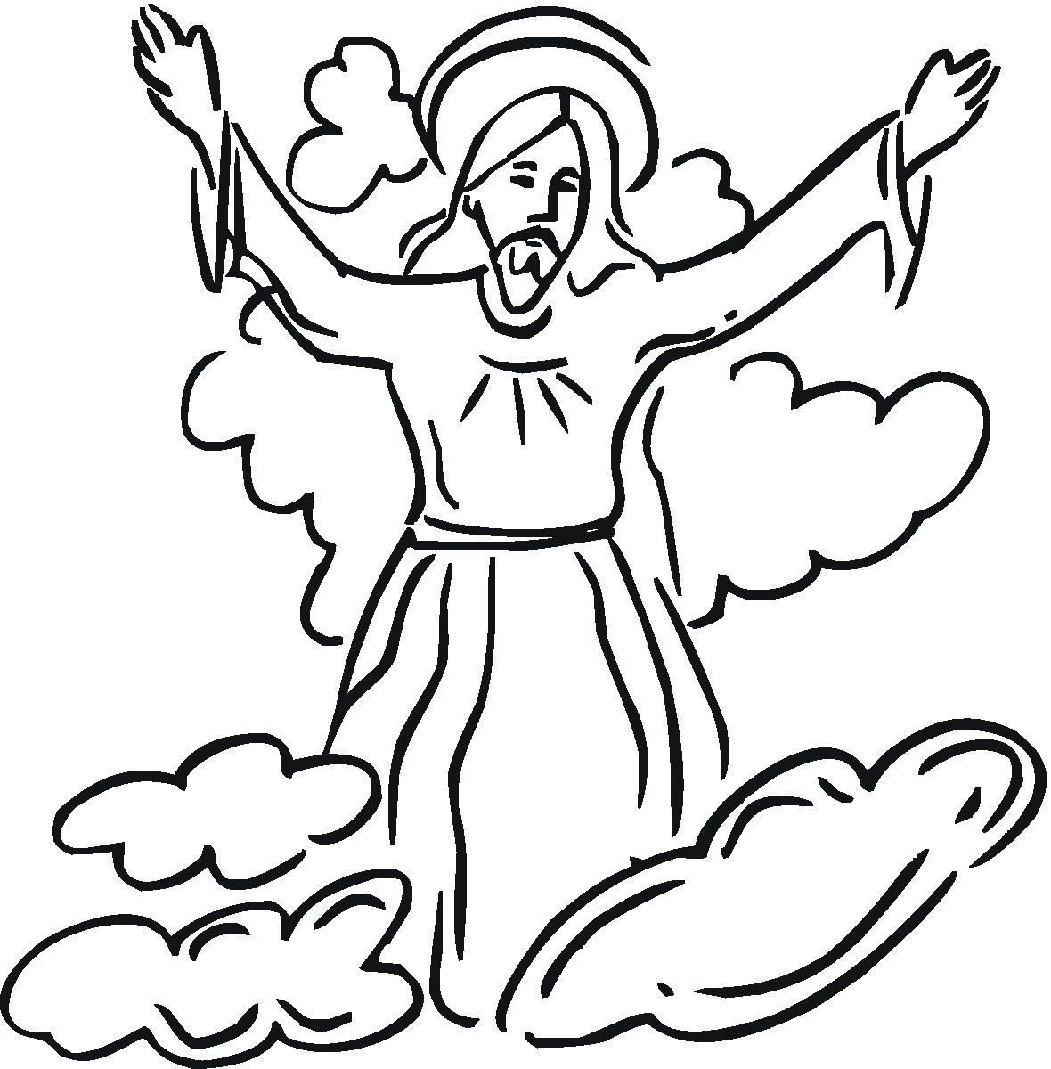

- What part do you have in God’s plans for the world?

Conclusion: Jesus came into the world to ________ it. Jesus’ work was to live a

___________ life and then _______ a complete, all-atoning ________________.

Closing Prayer: Thank you for showing Jesus to be the perfect sacrifice for sin, and for being my Lord and Savior. Thank you taking my place so that when I die I know that I will be in heaven with you forever. In Jesus’ name I pray. Amen.

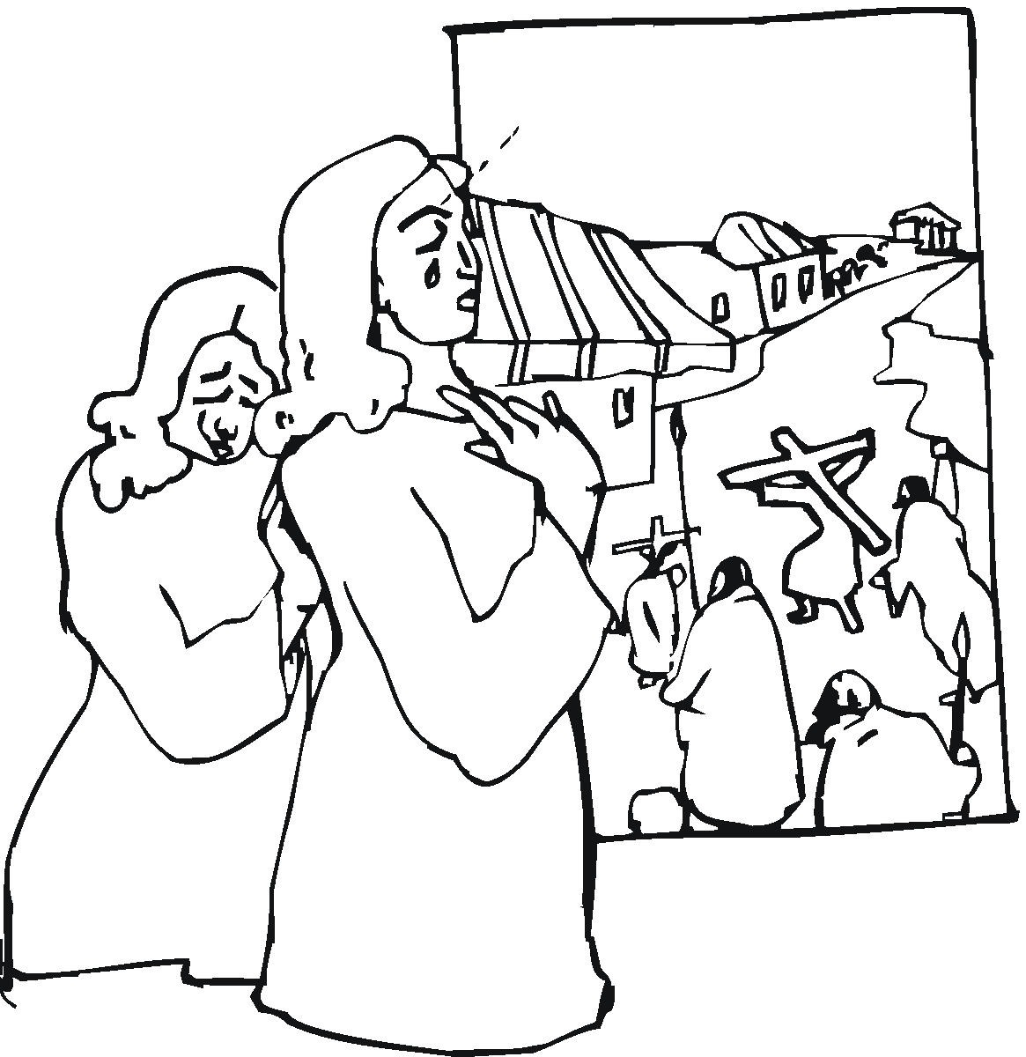

Scripture quotations are taken from the HOLY BIBLE, NEW INTERNATIONAL READER’S VERSION® (NIrV). NIV®. Copyright© 1994, 1996 by International Bible Society. Used by permission of Zondervan. All rights reserved.

