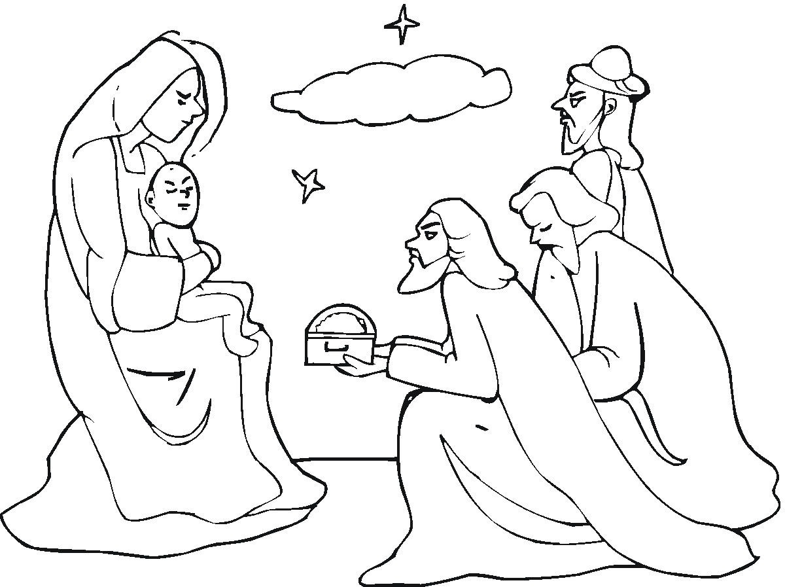
CHRIST, THE SAVIOR, IS COMING!

Opening Prayer: O Lord, our Lord, how excellent is your name in all the earth! We thank you for this opportunity to study your Word and ask that you would bless our study so we might better appreciate your promises and the fulfillment of those promises in Jesus as our Savior. In his name we ask it! Amen.

Read Acts 10:43 –
“All the prophets give witness about him. They say that all who believe in him have their sins forgiven through his name."

- What is a prophecy?

- Why has God revealed these prophecies to us?

LOOK AT THE PROPHECIES CONCERNING CHRIST’S COMING.

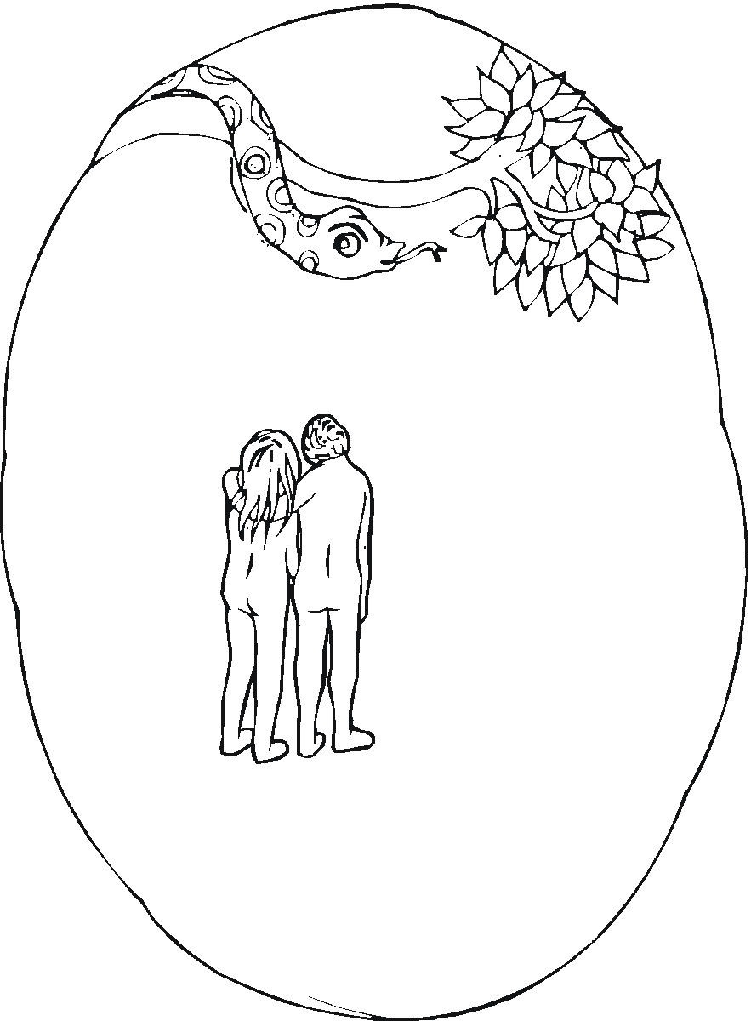
Read Genesis 3:15 –
I will put hatred between you and the woman. Your children and her children will be enemies. Her son will crush your head. And you will crush his heel."

Read Galatians 4:4 –
But then the right time came. God sent his Son. A woman gave birth to him. He was born under the authority of the law.

- Who is the son that will crush the devil’s head?
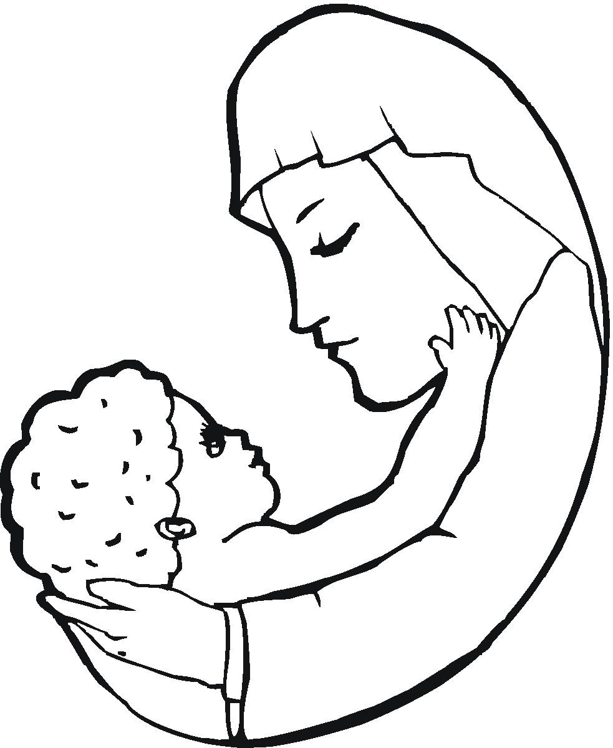

- Why did the Savior have to be “born of a woman?”

Read Isaiah 7:14 –
The Lord himself will give you a miraculous sign. The virgin is going to have a baby. She will give birth to a son. And he will be called Immanuel.

Read Matthew 1:18-25 –
18 This is how the birth of Jesus Christ came about. His mother Mary and Joseph had promised to get married. But before they started to live together, it became clear that she was going to have a baby. She became pregnant by the power of the Holy Spirit. 19 Her husband Joseph was a godly man. He did not want to put her to shame in public. So he planned to divorce her quietly.
20 But as Joseph was thinking about this, an angel of the Lord appeared to him in a dream. The angel said, "Joseph, son of David, don't be afraid to take Mary home as your wife. The baby inside her is from the Holy Spirit. 21 She is going to have a son. You must give him the name Jesus. That is because he will save his people from their sins." 22 All of this took place to bring about what the Lord had said would happen. He had said through the prophet, 23 "The virgin is going to have a baby. She will give birth to a son. And he will be called Immanuel."—(Isaiah 7:14) The name Immanuel means "God with us." 24 Joseph woke up. He did what the angel of the Lord commanded him to do. He took Mary home as his wife. 25 But he did not make love to her until after she gave birth to a son. And Joseph gave him the name Jesus.

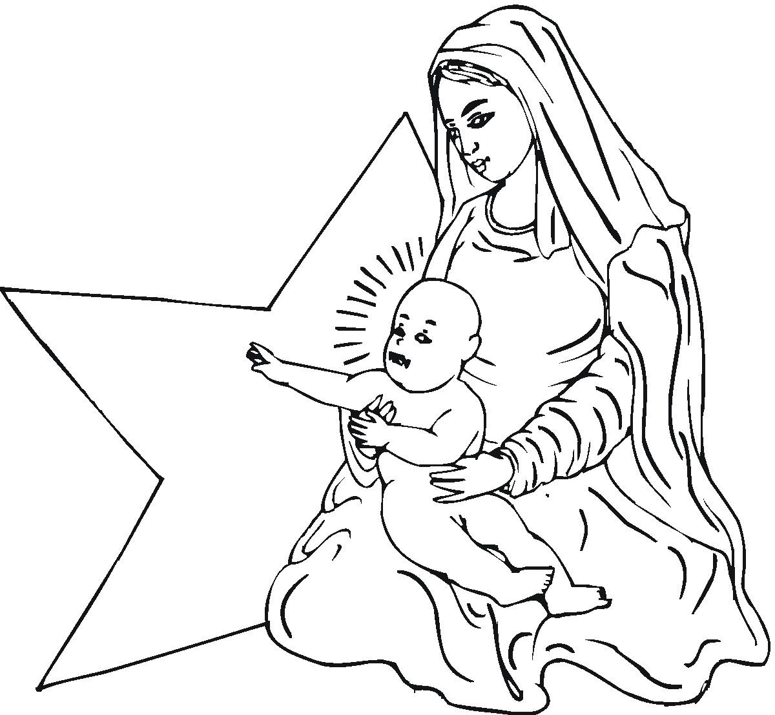
- What is the significance of the fact that Jesus was born of a virgin?

- What does it mean for us that Jesus is called “Immanuel?”

Read Micah 5:2 –
The Lord says, "Bethlehem, you might not be an important town in the nation of Judah. But out of you will come a ruler over Israel for me. His family line goes back to the early years of your nation. It goes all the way back to days of long ago." Bethlehem was also called Ephrathah.

Read Luke 2:4-5 –
4 So Joseph went also. He went from the town of Nazareth in Galilee to Judea. That is where Bethlehem, the town of David, was. Joseph went there because he belonged to the family line of David. 5 He went there with Mary to be listed. Mary was engaged to him. She was expecting a baby.

- What does it mean for us that God could tell us several hundred years before it happened just where Jesus would be born?

- How do we know that God will fulfill the other promises he makes to us?

Read Isaiah 9:7 –
The authority of his rule will continue to grow. The peace he brings will never end. He will rule on David's throne and over his kingdom. He will make the kingdom strong and secure. His rule will be based on what is fair and right. It will last forever. The Lord's great love will make sure that happens. He rules over all.

Read Luke 1:32-33 –
32 He will be great and will be called the Son of the Most High God. The Lord God will make him a king like his father David of long ago. 33 He will rule forever over his people, who came from Jacob's family. His kingdom will never end."

- Why would the fact that Jesus is a son of David have real meaning for the Jews?

- What do these words have to do with us today?

- What is the proper way for a Christian to prepare for Christmas?

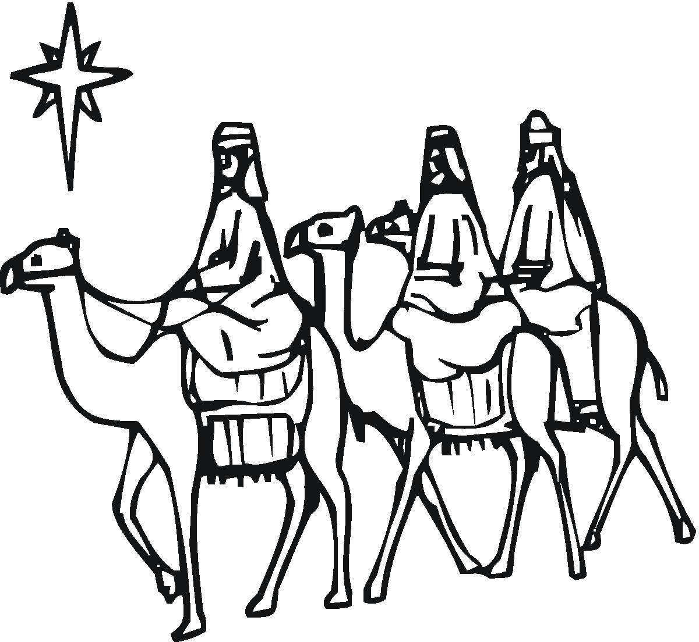

- What is the proper way for a Christian to celebrate Christmas?

- What memorable experiences do you have about Christmases past?


- What changes might you make in your celebration of Christmas in the future based on what you now know about God’s part in Christmas?

Closing prayer: Lord God, when you make a promise you keep it! Thank you for making the promises to your people that you would send a Savior who would take away their sin. Thank you for sending Jesus in fulfillment of that promise. Thank you for taking away all of our sins. Continue to bless us that our celebration of Christmas might put you as the most important part of Christmas. In Jesus’ name we ask it. Amen.

Scripture quotations are taken from the HOLY BIBLE, NEW INTERNATIONAL READER’S VERSION®(NIrV). NIV®. Copyright© 1994, 1996 by International Bible Society. Used by permission of Zondervan. All rights reserved.

