BIBLE STUDY – CHRIST’S SERMON ON THE MOUNT - 6
What About the Golden Rule – Do Unto Others? – Matthew 7:1-12
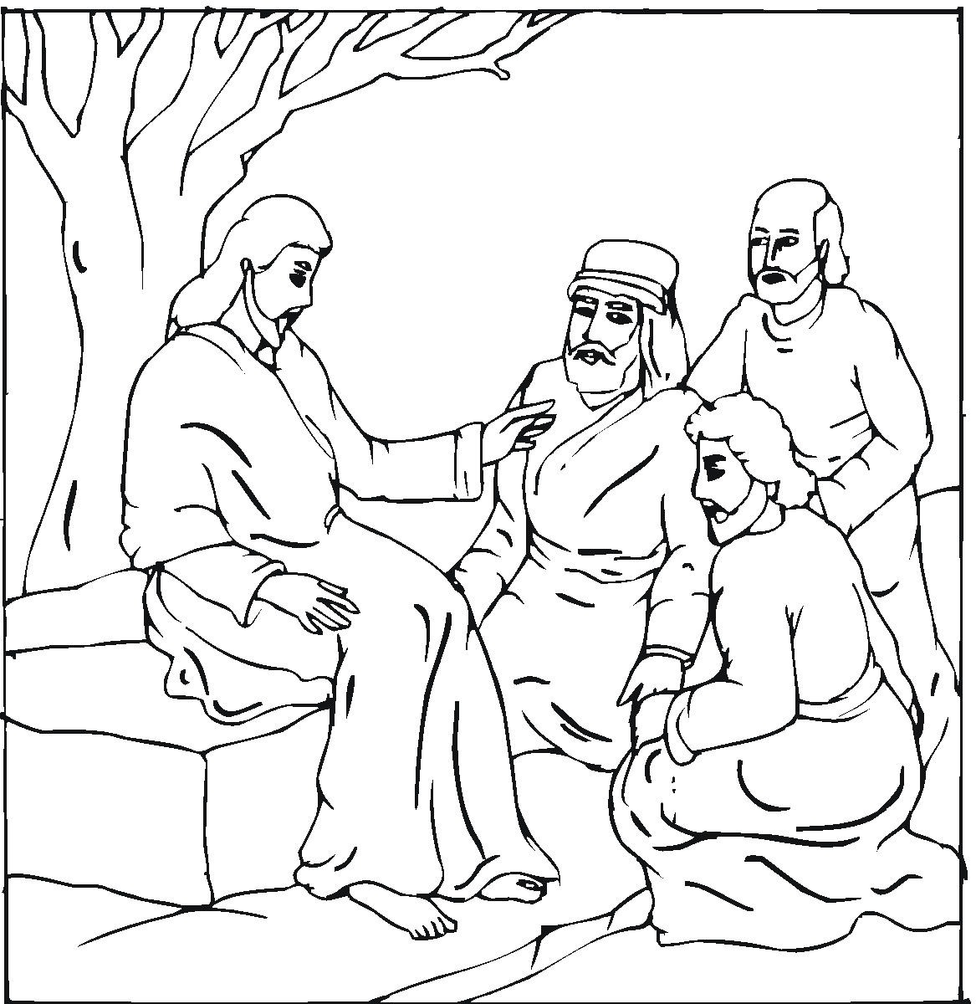
OPENING PRAYER: O Lord, we thank you for revealing yourself to us in your holy Word. Send your Holy Spirit to open our hearts and open our understanding that we not only know you as Lord and Savior but that we also live as your children every day of our lives. In your name we ask it. Amen.

INTRODUCTION: The Sermon on the Mount was directed primarily to his disciples (and thus to us as his believers today). (Matthew 5:1-2: ¹ Jesus saw the crowds. So he went up on a mountainside and sat down. His disciples came to him. ² Then he began to teach them.) As we study Jesus’ Sermon the Mount we must remember that we are not made right with God by our keeping the law, but through the grace of God in Christ Jesus. The law serves to show us our sin, to stop outbreaks of sin, and as a guide for the Christian. In this portion of the sermon Jesus talks about judging and criticizing others and how we should apply the Golden Rule.

BE FAIR WHEN YOU JUDGE OTHERS – Matthew 7:1-5
The Sin of Judging

Read 7:1-2: ¹ "Do not judge others. Then you will not be judged. ² You will be judged in the same way you judge others. You will be measured in the same way you measure others.
Jesus is here speaking of making judgments that only God can make – judging the heart and judging motives.
- When would it be appropriate to judge?

The Hypocrisy of Judging

Read 7:3-5: ³ "You look at the bit of sawdust in your friend's eye. But you pay no attention to the piece of wood in your own eye. ⁴ How can you say to your friend, 'Let me take the bit of sawdust out of your eye'? How can you say this while there is a piece of wood in your own eye? ⁵ "You pretender! First take the piece of wood out of your own eye. Then you will be able to see clearly to take the bit of sawdust out of your friend's eye.

- How do we take the bit of sawdust out of our eye?

COUNSELING ON THE USE OF GOD’S WORD – Matthew 7:6
Read 7:6: ⁶ "Do not give holy things to dogs. Do not throw your pearls to pigs. If you do, they might walk all over them. Then they might turn around and tear you to pieces.
The Gospel (“holy things…pearls”) is not to be offered to those (“dogs…pigs”) who have repeatedly rejected God’s call to repentance and faith. They might use it to fight against the very things you are proclaiming.
- Why do unbelievers become so defensive in their opposition to the Gospel of Christ?

THE ASSURANCE THAT GOD ANSWERS PRAYER – Matthew 7:7-11
God Commands us to Pray and Promises to Hear

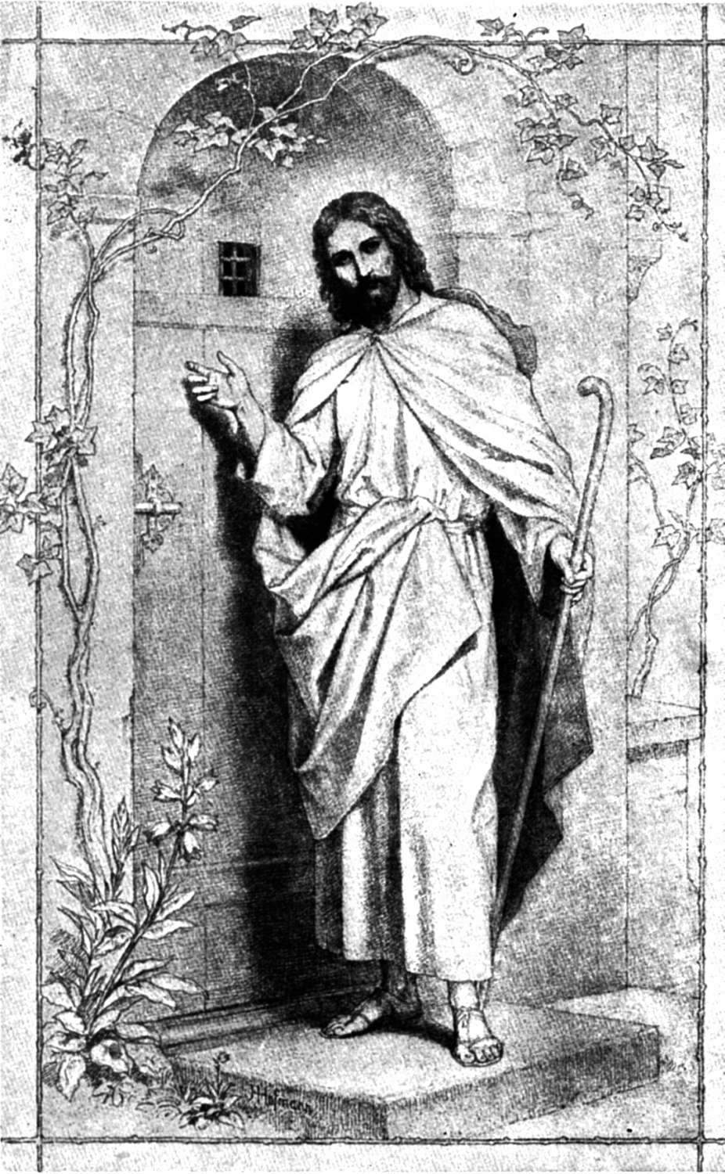
Read 7:7-8: ⁷ "Ask, and it will be given to you. Search, and you will find. Knock, and the door will be opened to you. ⁸ Everyone who asks will receive. He who searches will find. The door will be opened to the one who knocks.
The words here indicate that we are to keep on asking, keep on searching, and keep on knocking. The Lord wants us to be persistent in prayer and he assures us he will answer.
- Why can we not expect to receive an answer to our prayers if we pray with a doubting heart?

5. Why is it so difficult for us to be persistent in prayer?


We Pray as Children Asking their Father
Read 7:9-11: ⁹ "Suppose your son asks for bread. Which of you will give him a stone? ¹⁰ Or suppose he asks for a fish. Which of you will give him a snake? ¹¹ Even though you are evil, you know how to give good gifts to your children. How much more will your Father who is in heaven give good gifts to those who ask him!
Jesus uses an extreme contrast to illustrate how much he loves us – loves us so much that he was willing to allow his Son to die for us that we might have forgiveness of sins and eternal life in heaven. He does this even though we are “evil,” that is, we have our sinful nature that needs that forgiveness.
- What is the best gift that our God gives us?

- What is the best gift that you could give your children?

- If you son wanted a new Corvette for his 16th birthday why might you not give it to him (even if you could afford it)?

- Why does God not give us everything we ask for at the time we ask for it?

THE GOLDEN RULE – Matthew 7:12
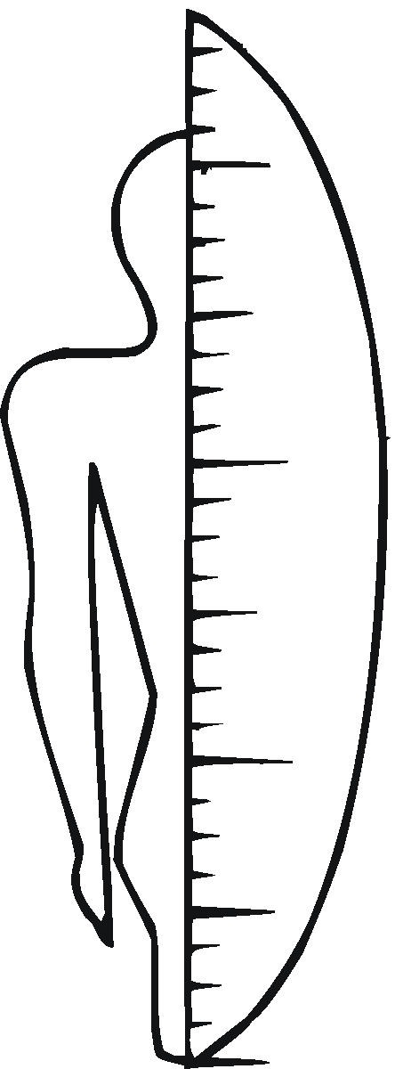
Read 7:12: ¹² "In everything, do to others what you would want them to do to you. This is what is written in the Law and in the Prophets.
As believers we need to remember that we can do good only as God’s love for us moves us to love and show love for others. We don’t do good to others with the selfish motive of getting others to do good to us, but rather we do good in a way that we would want others to treat us in similar circumstances. The example of the right kind of love is shown in God’s Word.
- Why is it so difficult for the Christian to put the Golden Rule into practice?

- Why is it so necessary for the Christian to be studying the Bible regularly?

- What have you learned in this lesson about the Golden Rule?

Scripture taken from the Holy Bible, NEW INTERNATIONAL READER'S VERSION®.Copyright © 1996, 1998 International Bible Society. All rights reserved throughout the world. Used by permission of International Bible Society.

Material for this lesson was adapted from “The Sermon on the Mount,” by Donald E. Kolander, Northwestern Publishing House, Milwaukee, Wisconsin 1973.

