BIBLE STUDY – CHRIST’S SERMON ON THE MOUNT - 7
How Should I Respond When Jesus Says, “Follow Me”?
Matthew 7:13-27
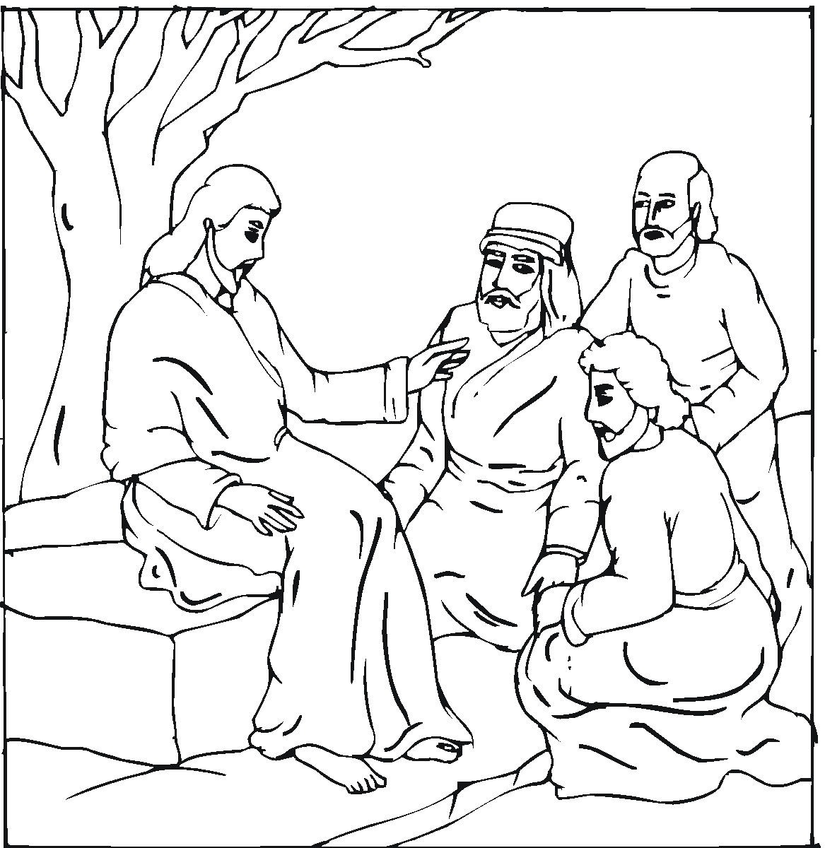
OPENING PRAYER: O Lord, we thank you for revealing yourself to us in your holy Word. Send your Holy Spirit to open our hearts and open our understanding that we not only know you as Lord and Savior but that we also live as your children every day of our lives. In your name we ask it. Amen.

INTRODUCTION: The Sermon on the Mount was directed primarily to his disciples (and thus to us as his believers today). (Matthew 5:1-2: ¹ Jesus saw the crowds. So he went up on a mountainside and sat down. His disciples came to him. ² Then he began to teach them.) As we study Jesus’ Sermon the Mount we must remember that we are not made right with God by our keeping the law, but through the grace of God in Christ Jesus. The law serves to show us our sin, to stop outbreaks of sin, and as a guide for the Christian. In this portion of the sermon Jesus guides us in our Christian walk of faith.

THE LARGE AND SMALL GATES – Matthew 7:13-14
Read 7:13-14: ¹³ "Enter God's kingdom through the narrow gate. The gate is large and the road is wide that lead to death and hell. Many people go that way. ¹⁴ But the gate is small and the road is narrow that lead to life. Only a few people find it.
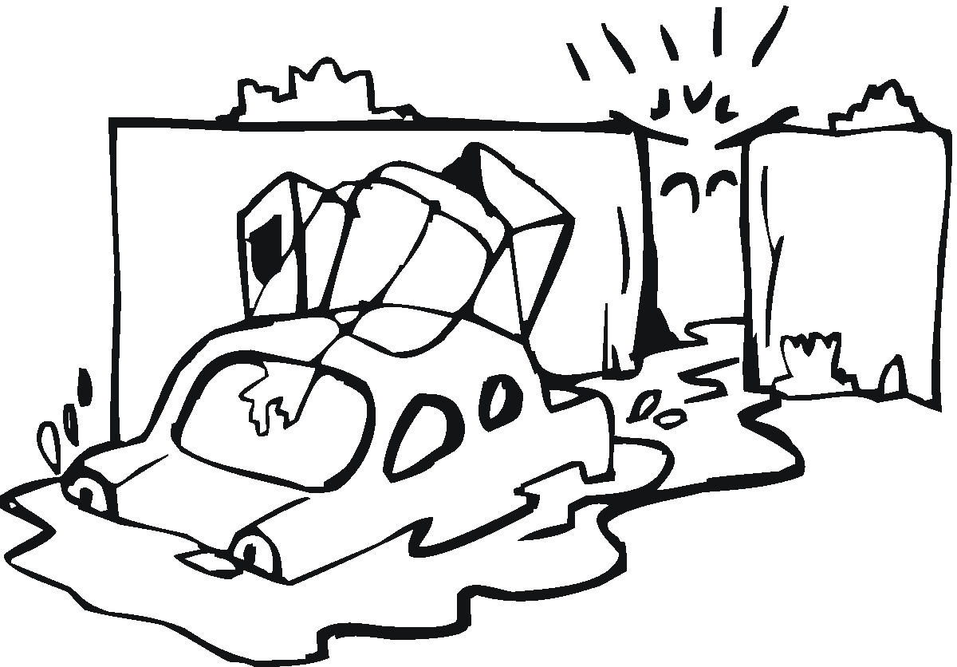
- What does Jesus mean when he says only a few people find the narrow way that leads to life?

- Why wouldn’t everyone want to go to heaven after they die?

A TREE AND ITS FRUIT – Matthew 7:15-23
False Teachers Can Be Deceptive

Read 7:15: ¹⁵ "Watch out for false prophets. They come to you pretending to be sheep. But on the inside they are hungry wolves.
- Why is the message of a false prophet so dangerous?

False Teachers Are Recognized By Their Fruits
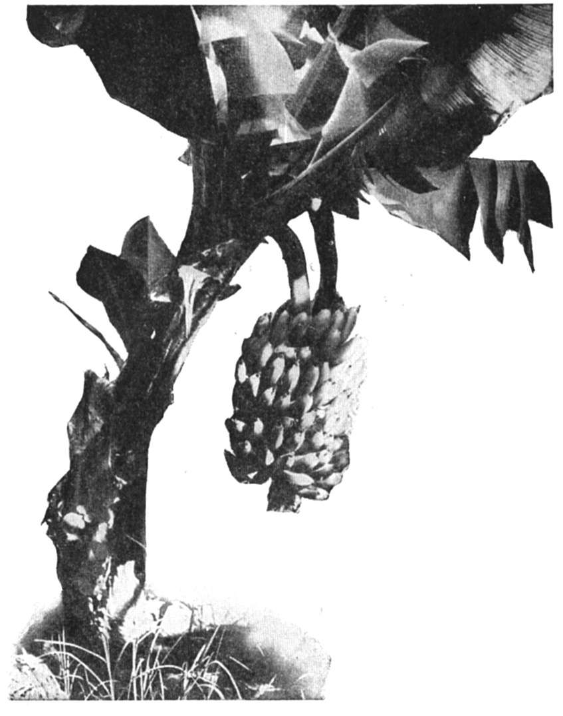
Read 7:16-18, 20: ¹⁶ You can tell what they really are by what they do. "Do people pick grapes from bushes? Do they pick figs from thorns? ¹⁷ In the same way, every good tree bears good fruit. But a bad tree bears bad fruit. ¹⁸ A good tree can't bear bad fruit. And a bad tree can't bear good fruit... ²⁰ You can tell each tree by its fruit.”
- How do we examine the “fruit” of one who is claiming to preach the gospel?

False Teachers Are To Be Dealt With As Imposters
Read 7:19: ¹⁹ Every tree that does not bear good fruit is cut down. It is thrown into the fire.
- If the false prophet is “cut down” in God’s judgment what about those who follow the false prophet?

False Teachers Are Not Acknowledged By The Lord Of The Church
Read 7:21-23: ²¹ "Not everyone who says to me, 'Lord, Lord,' will enter the kingdom of heaven. Only those who do what my Father in heaven wants will enter. ²² "Many will say to me on that day, 'Lord! Lord! Didn't we prophesy in your name? Didn't we drive out demons in your name? Didn't we do many miracles in your name?' ²³ Then I will tell them clearly, 'I never knew you. Get away from me, you who do evil!'

- What is the relationship between following God’s Word and following human reason?

- What does it mean to “do what my Father in heaven wants?”
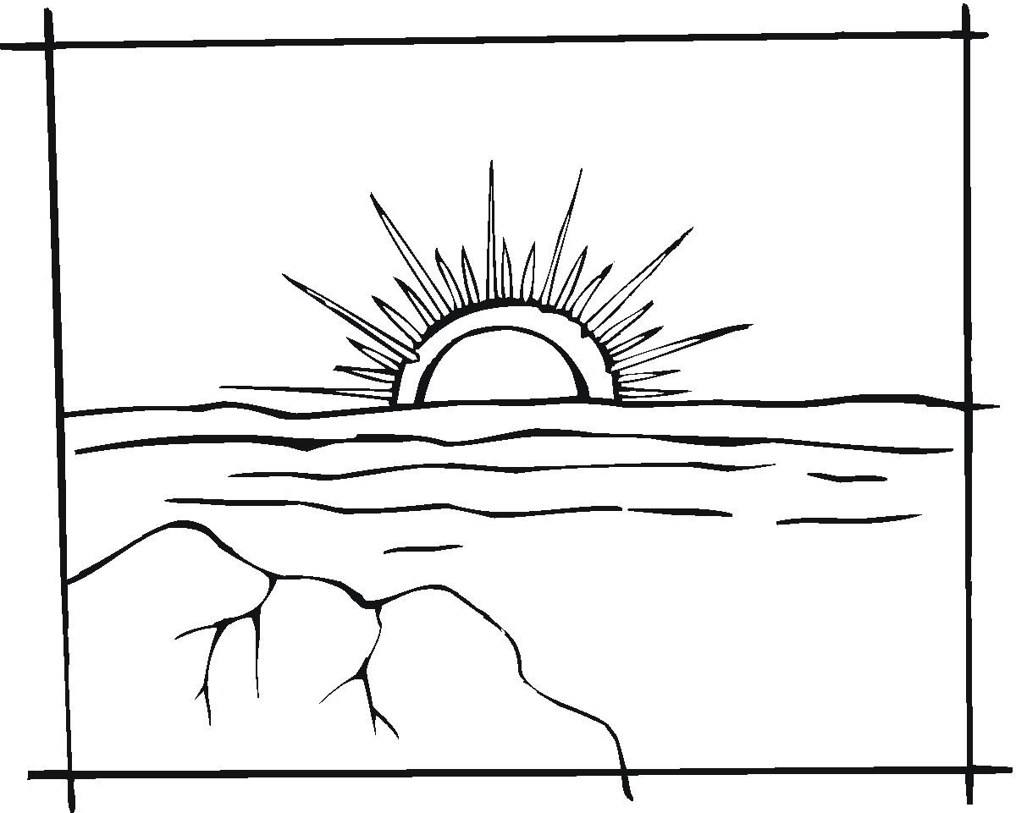
- What is “that day” of which Jesus is speaking?

- Why doesn’t the Christian have to be afraid to die and face the Lord?

THE WISE AND FOOLISH BUILDERS – Matthew 7:24-27
Build On A Strong Foundation
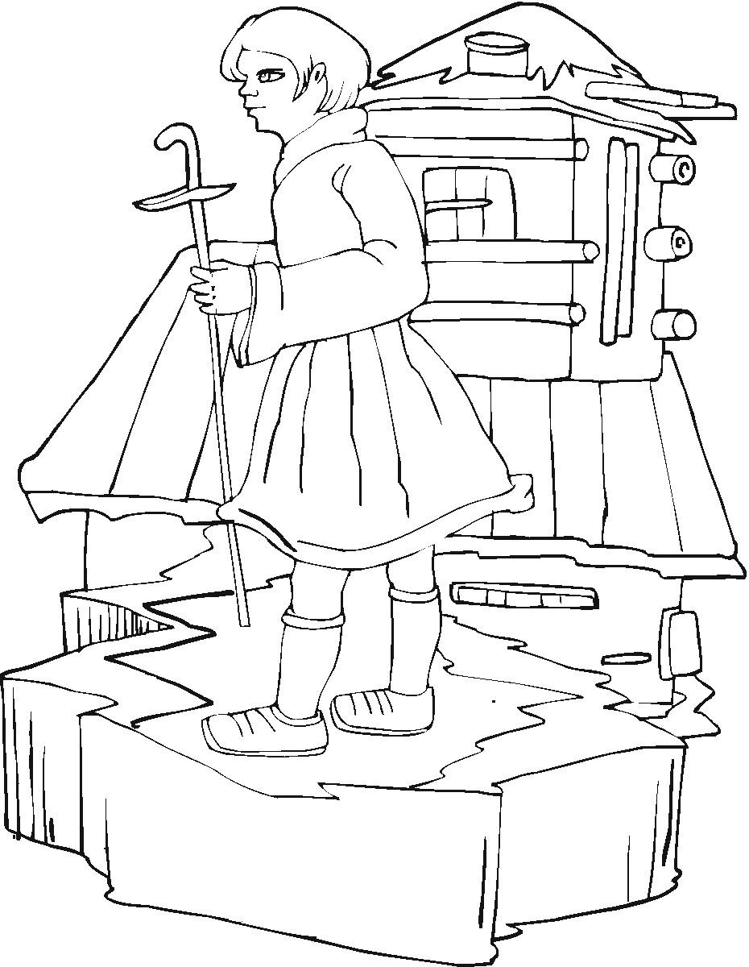
Read 7:24-25: ²⁴ "So then, everyone who hears my words and puts them into practice is like a wise man. He builds his house on the rock. ²⁵ The rain comes down. The water rises. The winds blow and beat against that house. But it does not fall. It is built on the rock.
- How can we as Christians withstand all of the temptations of the devil, of the sinful world in which we live, and of our own sinful flesh?

11. What is the “rock” on which we are to build our lives?

Building Without Christ Will Result In Destruction And Disaster
Read 7:26-27: ²⁶ "But everyone who hears my words and does not put them into practice is like a foolish man. He builds his house on sand. ²⁷ The rain comes down. The water rises. The winds blow and beat against that house. And it falls with a loud crash."
- Why is faith in Christ and a life grounded in Christ so important?

- Will God really send those who reject him to spend an eternity in hell, separated from him? Explain.

Read 7:28: ²⁸ Jesus finished saying all these things. The crowds were amazed at his teaching. ²⁹ He taught like one who had authority. He did not speak like their teachers of the law.
- What difference will this study of the Sermon on the Mount make in your life?

Scripture taken from the Holy Bible, NEW INTERNATIONAL READER'S VERSION®.Copyright © 1996, 1998 International Bible Society. All rights reserved throughout the world. Used by permission of International Bible Society.

Material for this lesson was adapted from “The Sermon on the Mount,” by Donald E. Kolander, Northwestern Publishing House, Milwaukee, Wisconsin 1973.

