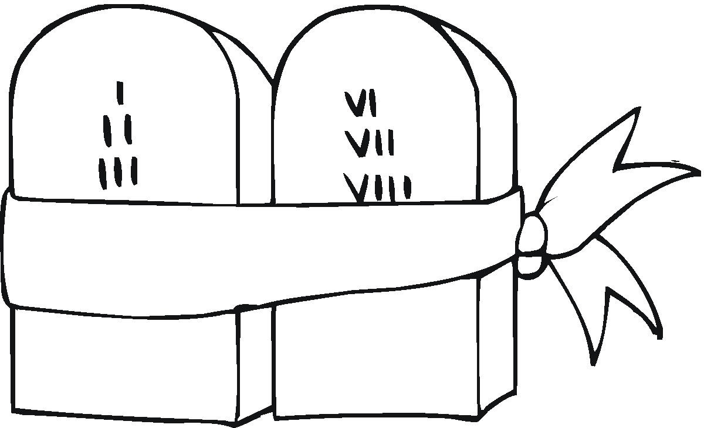

GOD’S WILL FOR OUR LIVES
(An Eleven Part Bible Study on the Ten Commandments)

Part 6 – The Fifth Commandment


You shall not murder.
What does this mean?
We should fear and love God that we do not hurt nor harm our neighbor in his body, but help and be a friend to him in every bodily need.

INTRODUCTION
- Prayer – Dear Lord, we thank you for the blessing of life and we pray that you will help us understand the blessings of life, not only life here but also the blessings of eternal life you have prepared for us. In Jesus’ name we ask it. Amen!

- The most precious earthly gift God has given us is the gift of life. It is as though he puts a protective shield around us and says, “Hands off, this life is mine; I gave it and I alone have the right to end it.”

- God not only forbids us to take the life of another, he also directs us in a positive way to help preserve the lives of others.

WHAT GOD TEACHES ABOUT LIFE
- Life on this earth is a time of God’s grace.
  - Isaiah 55:6: Turn to the Lord before it's too late. Call out to him while he's still ready to help you.
- God wants everyone to come to know and believe in him during their lifetimes. How do people sometimes interfere with this will of God?

- Life on this earth is in God’s hands.
  - Psalm 31:15: My whole life is in your hands. Save me from my enemies. Save me from those who are chasing me.
- In what way is our life in God’s hands?


- Life begins at the time of conception.
  - Psalm 139:13-16: 13 You created the deepest parts of my being. You put me together inside my mother's body. 14 How you made me is amazing and wonderful. I praise you for that. What you have done is wonderful. I know that very well. 15 None of my bones was hidden from you when you made me inside my mother's body. That place was as dark as the deepest parts of the earth. When you were putting me together there, 16 your eyes saw my body even before it was formed. You planned how many days I would live. You wrote down the number of them in your book before I had lived through even one of them.
- Why is abortion murder?

  - Deuteronomy 32:39: "Look! I am the One! There is no other God except me. I put some people to death. I bring others to life. I have wounded, and I will heal. No one can save you from my powerful hand.
- When do people try to play “God” with people’s lives?

  - Genesis 9:6: "Anyone who murders man will be killed by man. That is because I have made man
in my own likeness.
- Why does God give the government the right of capital punishment?

  - Romans 14:4: Who are you to judge someone else's servants? Whether they are faithful or not is their own master's concern. They will be faithful, because the Lord has the power to make them faithful.
6. When may a government abuse the right they have to exercise capital punishment?

WHAT DOES GOD FORBID IN THIS FIFTH COMMANDMENT?
- God forbids suicide.
  - Matthew 27:5: So Judas threw the money into the temple and left. Then he went away and hanged himself.
7. What is wrong with the statement, “My life is my own. If I want to kill myself that is my business!”?

- God forbids murder.
  - Genesis 4:2-9: 2 Later she gave birth to his brother Abel. Abel took care of sheep. Cain worked the ground. 3 After some time, Cain gathered some of the things he had grown. He brought them as an offering to the Lord. 4 But Abel brought the fattest parts of some of the lambs from his flock. They were the male animals that were born first to their mothers. The Lord was pleased with Abel and his offering. 5 But he wasn't pleased with Cain and his offering. So Cain became very angry. His face was sad. 6 Then the Lord said to Cain, "Why are you angry? Why are you looking so sad? 7 Do what is right. Then you will be accepted. If you don't do what is right, sin is waiting at your door to grab you. It longs to have you. But you must rule over it." 8 Cain said to his brother Abel, "Let's go out to the field." So they went out. There Cain attacked his brother Abel and killed him. 9 Then the Lord said to Cain, "Where is your brother Abel?" "I don't know," he replied. "Am I supposed to look after my brother?"
8. What is the cause of so many murders today?

- God forbids killing through carelessness.
  - Exodus 21:29: "But suppose the bull has had the habit of attacking people. And suppose the owner has been warned but has not kept it fenced in. Then if it kills a man or woman, you must kill it with stones. The owner must also be put to death.
9. How might we become guilty of killing by carelessness?

  - Deuteronomy 22:8: If you build a new house, put a low wall around the edge of your roof. Then you won't be held accountable if someone falls off your roof and dies.
10. Is an employer responsible for the safety of his employees? Explain your answer.


- God forbids hurting or harming our neighbor in any way.
  - Luke 10:30: Jesus replied, "A man was going down from Jerusalem to Jericho. Robbers attacked him. They stripped off his clothes and beat him. Then they went away, leaving him almost dead.
11. Why is this breaking the fifth commandment?

  - Matthew 5:21-22: 21 "You have heard what was said to people who lived long ago. They were told, 'Do not commit murder.—(Exodus 20:13) Anyone who murders will be judged for it.' 22 But here is what I tell you. Do not be angry with your brother. Anyone who is angry with his brother will be judged. Again, anyone who says to his brother, 'Raca,' must stand trial in the Sanhedrin. But anyone who says, 'You fool!' will be in danger of the fire in hell.
12. Why is anger and calling someone stupid (“raca”) breaking this commandment?

- God forbids abusing one’s own body.
  - Deuteronomy 21:20-21: 20 They will say to the elders, "This son of ours is very stubborn. He won't obey us. He wastes his money. He's always getting drunk." 21 Then all of the people in his town will put him to death by throwing stones at him. Get rid of that evil person. All of the people of Israel will hear about it. And they will be afraid to disobey their parents.
13. Would drug abuse also be included here? Explain your answer.

- God forbids anger and hatred.
  - Matthew 5:22: But here is what I tell you. Do not be angry with your brother. Anyone who is angry with his brother will be judged. Again, anyone who says to his brother, 'Raca,' must stand trial in the Sanhedrin. But anyone who says, 'You fool!' will be in danger of the fire in hell.
14. Under what circumstances is it all right to be angry?

  - 1 John 3:15: 15 Those who hate their brothers and sisters are murderers. And you know that murderers do not have eternal life in their hearts.
15. Why is hatred so dangerous?

WHAT DOES GOD REQUIRE IN THIS FIFTH COMMANDMENT?
- God wants us to assist our neighbor and be a real friend to him or her.
  - Luke 10:33-35: 33 But a Samaritan came to the place where the man was. When he saw the man, he felt sorry for him. 34 He went to him, poured olive oil and wine on his wounds and bandaged them. Then he put the man on his own donkey. He took him to an inn and took care of him. 35 The next day he took out two silver coins. He gave them to the owner of the inn. 'Take care of him,' he said. 'When I return, I will pay you back for any extra expense you may have.'
16. What kind of opportunities does God give you to exercise your faith?



  - Genesis 14:12-16: 12 They carried away Lot, Abram's nephew, and the things he owned. Lot was living in Sodom at that time. 13 One man escaped. He came and reported everything to Abram. Abram was a Hebrew. He was living near the large trees of Mamre the Amorite. Mamre was a brother of Eshcol and Aner. All of them helped Abram. 14 Abram heard that Lot had been captured. So he called out his 318 trained men. All of them were sons of his servants. They chased the enemy as far as Dan. 15 During the night Abram separated his men into groups. They attacked the enemy and drove them away. They chased them north of Damascus as far as Hobah. 16 Abram took back all of the things the kings had taken. He brought back his nephew Lot and the things Lot owned. He also brought back the women and the other people.
17. How could you help someone who is in danger?

  - Romans 12:20: Scripture says, "If your enemies are hungry, give them food to eat. If they are thirsty, give them something to drink. By doing those things, you will pile up burning coals on their heads." —(Proverbs 25:21,22)
18. Why is it so difficult to help others, especially our enemies?

- God wants us to forgive our neighbor when he sins against us.
  - Matthew 18:21-35: 21 Peter came to Jesus. He asked, "Lord, how many times should I forgive my brother when he sins against me? Up to seven times?" 22 Jesus answered, "I tell you, not seven times, but 77 times. 23 "The kingdom of heaven is like a king who wanted to collect all the money his servants owed him. 24 As the king began to do it, a man who owed him millions of dollars was brought to him. 25 The man was not able to pay. So his master gave an order. The man, his wife, his children, and all he owned had to be sold to pay back what he owed. 26 "The servant fell on his knees in front of him. 'Give me time,' he begged. 'I'll pay everything back.' 27 "His master felt sorry for him. He forgave him what he owed and let him go. 28 "But then that servant went out and found one of the other servants who owed him a few dollars. He grabbed him and began to choke him. 'Pay back what you owe me!' he said. 29 "The other servant fell on his knees. 'Give me time,' he begged him. 'I'll pay you back.' 30 "But the first servant refused. Instead, he went and had the man thrown into prison. The man would be held there until he could pay back what he owed. 31 The other servants saw what had happened. It troubled them greatly. They went and told their master everything that had happened. 32 "Then the master called the first servant in. 'You evil servant,' he said. 'I forgave all that you owed me because you begged me to. 33 Shouldn't you have had mercy on the other servant just as I had mercy on you?' 34 In anger his master turned him over to the jailers. He would be punished until he paid back everything he owed. 35 "This is how my Father in heaven will treat each of you unless you forgive your brother from your heart."
19. What are the consequences for not forgiving another person?

  - Ephesians 4:32: 32 Be kind and tender to one another. Forgive each other, just as God forgave you because of what Christ has done.
20. Why is it so difficult to forgive and forget what others have done to us?

OUR RESPONSE
  - Listen to St. Paul: (2 Corinthians 5:14): Christ's love controls us. We are sure that one person died for everyone. And so everyone died.
  - Listen to Jesus: (John 13:15): I have given you an example. You should do as I have done for you.

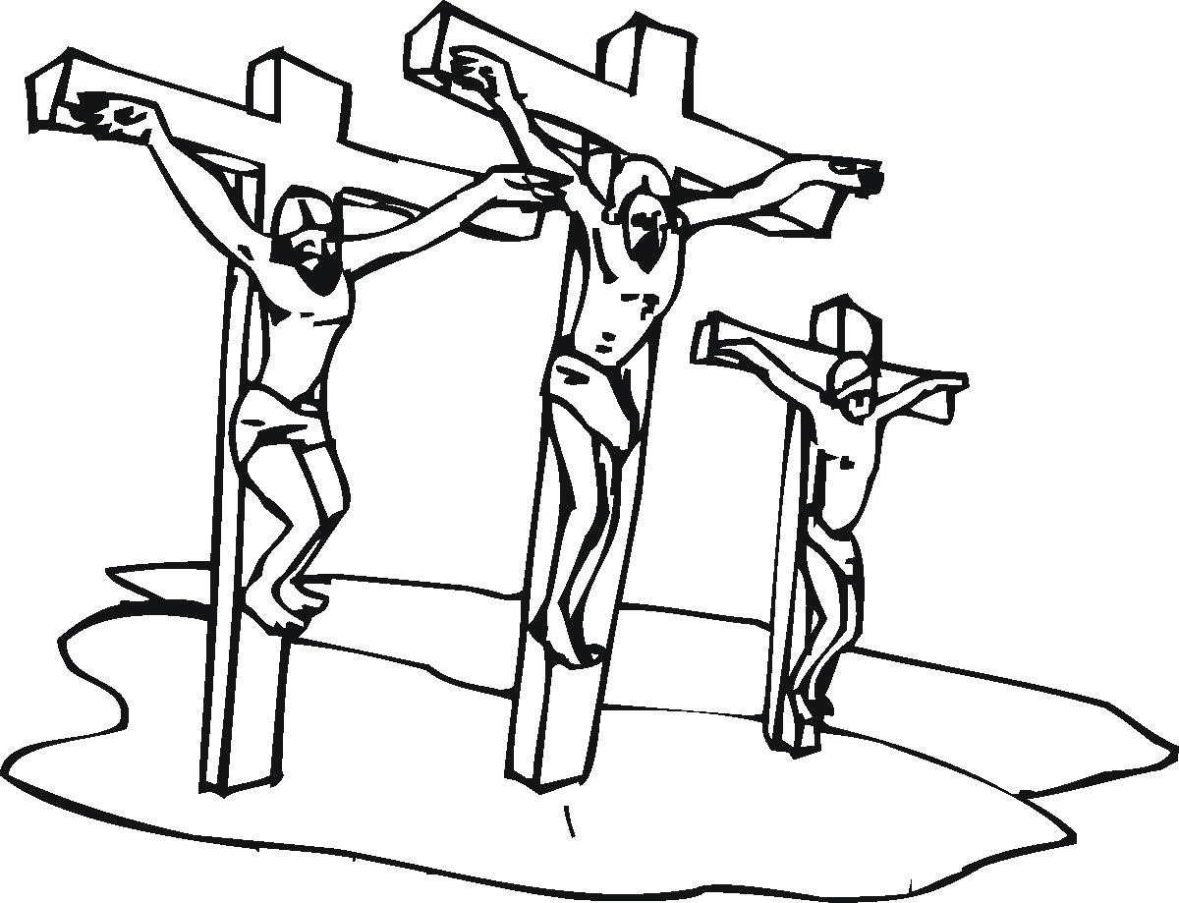

Scripture quotations are taken from the HOLY BIBLE, NEW INTERNATIONAL READER’S VERSION® (NIrV). NIV®. Copyright© 1994, 1996 by International Bible Society. Used by permission of Zondervan. All rights reserved.

Adapted from “God’s Will for our Lives” by William E. Fischer, copyright 1973, Northwestern Publishing House, Milwaukee, Wisconsin.

