WOMEN OF THE BIBLE – REBEKAH

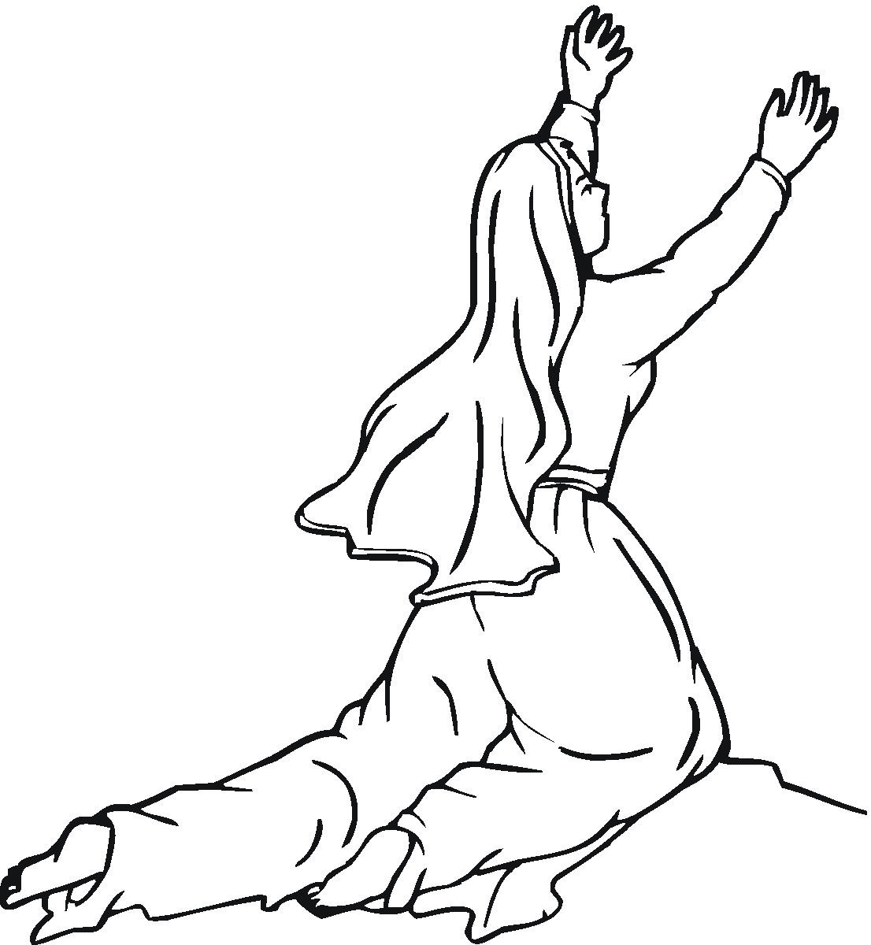
PRAYER: O Lord God, heavenly Father, you have called sinful human beings to be your servants. Thank you for women like Rebekah. Help me to believe that all my sins were paid for by Jesus my Savior and the Holy Spirit is at work through the Word to strengthen me in my faith and in my life. Help me always to serve you faithfully even if those around me do not. I ask it in Jesus’ name. Amen.

INTRODUCTION: The women of the Bible make an interesting study of faith and life. Like every woman they all carry the baggage of sin on their shoulders. In this study we will see how the Lord’s grace and mercy reached out to faithful Rebekah and how God blessed her and his people through her.

BACKGROUND: Rebekah’s marriage to Isaac (Abraham’s son) was definitely one of those unions we would describe as “made in heaven.” It’s a beautiful romantic story in which God’s hand was evident all the way, and had all the earmarks of “and they lived happily ever after.” But they didn’t! Despite a good beginning their marriage fell apart. From Rebekah’s negative example we can learn much about interpersonal relationships in a home, and, hopefully, avoid some of the pitfalls into which she and Isaac fell.
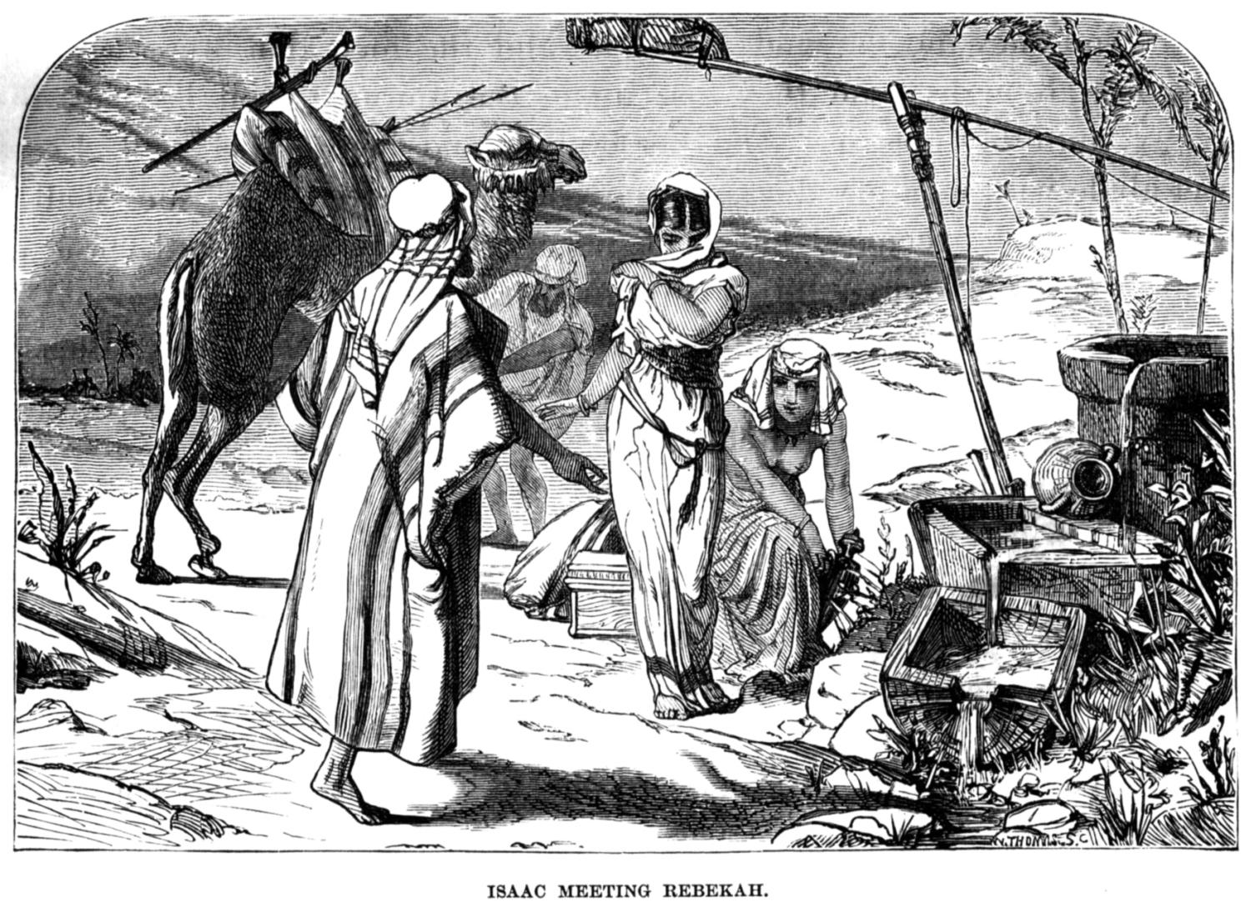
Read Genesis 24:1-67: This section tells how Abraham sent his servant Eliezer to find a wife for Isaac. The Lord led the servant to Rebekah and she willingly returned with him and married Isaac.

Read Genesis 25:19-34: Jacob and Esau
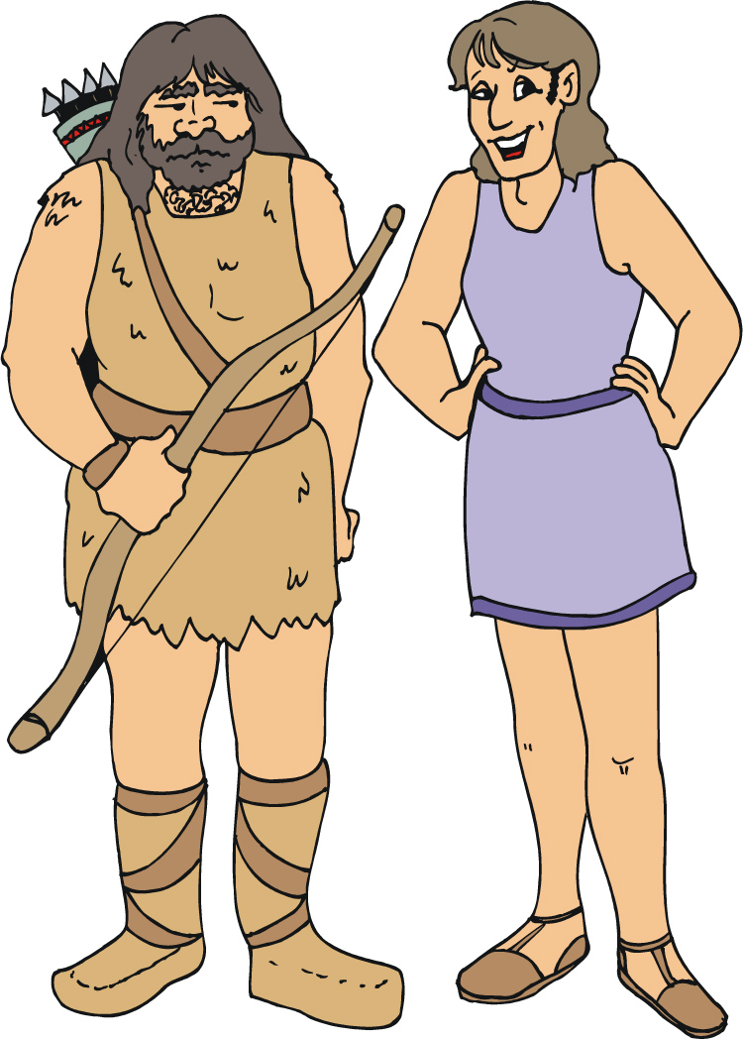
¹⁹ Here is the story of Abraham's son Isaac. Abraham was the father of Isaac. ²⁰ Isaac was 40 years old when he married Rebekah. She was the daughter of Bethuel the Aramean from Paddan Aram. She was also the sister of Laban the Aramean. ²¹ Rebekah couldn't have children. So Isaac prayed to the Lord for her. And the Lord answered his prayer. His wife Rebekah became pregnant. ²² The babies struggled with each other inside her. She said, "Why is this happening to me?" So she went to ask the Lord what she should do. ²³ The Lord said to her, "Two nations are in your body. Two tribes that are now inside you will be separated. One nation will be stronger than the other. The older son will serve the younger one." ²⁴ The time came for Rebekah to have her babies. There were twin boys in her body. ²⁵ The first one to come out was red. His whole body was covered with hair. So they named him Esau. ²⁶ Then his brother came out. His hand was holding onto Esau's heel. So he was named Jacob. Isaac was 60 years old when Rebekah had them. ²⁷ The boys grew up. Esau became a skillful hunter. He was a man who liked the open country. But Jacob was a quiet man. He stayed at home among the tents. ²⁸ Isaac liked the meat of wild animals. So Esau was his favorite son. But Rebekah's favorite was Jacob. ²⁹ One day Jacob was cooking some stew. Esau came in from the open country. He was very hungry. ³⁰ He said to Jacob, "Quick! Let me have some of that red stew! I'm very hungry!" That's why he was also named Edom. ³¹ Jacob replied, "First sell me the rights that belong to you as the oldest son in the family." ³² "Look, I'm dying of hunger," Esau said. "What good are those rights to me?" ³³ But Jacob said, "First promise me with an oath that you are selling me your rights." So Esau promised to do it. He sold Jacob all of the rights that belonged to him as the oldest son. ³⁴ Jacob gave Esau some bread and some lentil stew. Esau ate and drank. Then he got up and left. So Esau didn't care anything at all about the rights that belonged to him as the oldest son.

QUESTIONS:
- How did both Isaac and Rebekah respond to situations they didn’t understand or couldn’t control? (25:21-22)

- What does this response reveal about Isaac and Rebekah?

- What prediction did the Lord make to Rebekah about her children?

- How did this answer her questions in verse 22?

- What should she have realized was ahead of her in rearing these boys?

- In what ways were Esau and Jacob different?

- Why was Isaac partial to Esau and Rebekah to Jacob?

- Why is that kind of favoritism dangerous to family life?

- How did Jacob gain the advantage over Esau?

- What apparently was more important to Esau than his birthright?

- In preparing to give his patriarchal blessing to Esau, what had Isaac apparently forgotten?

- What still seemed to be a priority in his life?

Read Genesis 27:1 – 28:5: Isaac Gives Jacob His Blessing
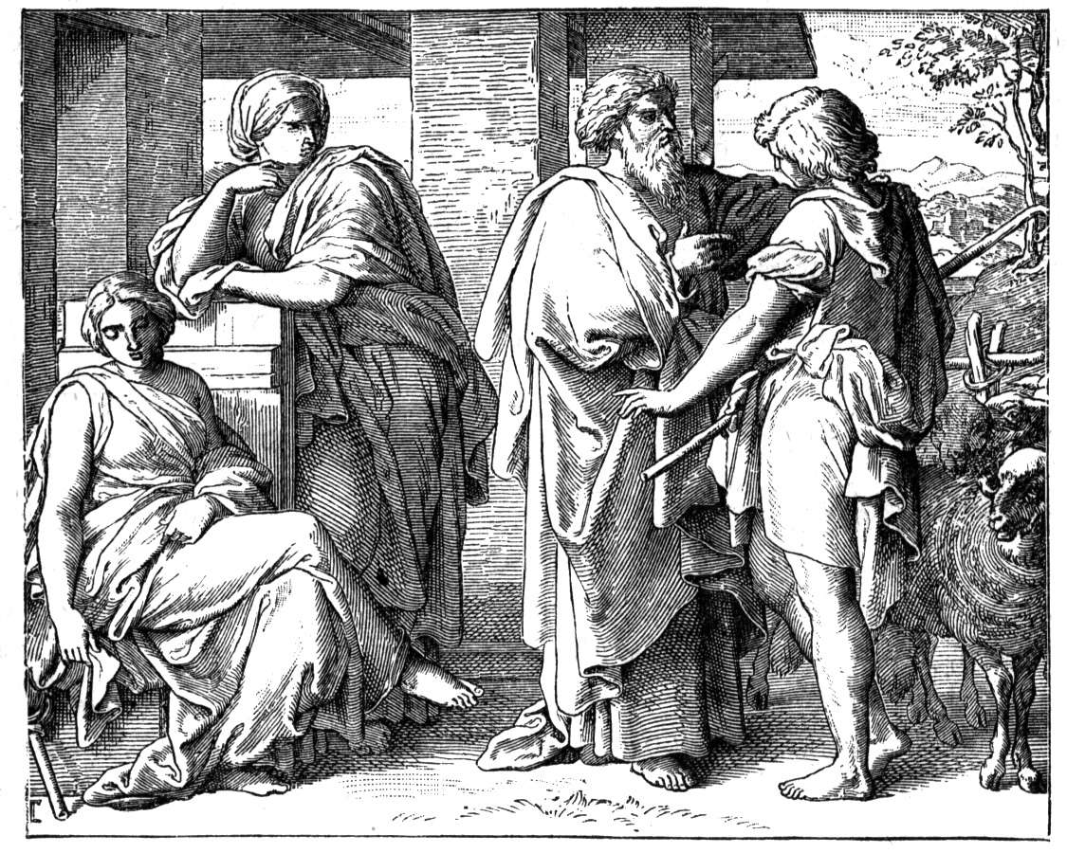
¹ Isaac had become old. His eyes were so weak he couldn't see anymore. One day he called for his older son Esau. He said to him, "My son." "Here I am," he answered. ² Isaac said, "I'm an old man now. And I don't know when I'll die. ³ Now then, get your weapons. Get your bow and arrows. Go out to the open country. Hunt some wild animals for me. ⁴ Prepare for me the kind of tasty food I like. Bring it to me to eat. Then I'll give you my blessing before I die." ⁵ Rebekah was listening when Isaac spoke to his son Esau. Esau left for the open country. He went to hunt for a wild animal and bring it back. ⁶ Then Rebekah said to her son Jacob, "Look, I heard your father speaking to your brother Esau. ⁷ He said, 'Bring me a wild animal. Prepare some tasty food for me to eat. Then I'll give you my blessing before I die. The Lord will be my witness.'" ⁸ Rebekah continued, "My son, listen carefully. Do what I tell you. ⁹ Go out to the flock. Bring me two of the finest young goats. I will prepare tasty food for your father. I'll make it just the way he likes it. ¹⁰ I want you to take it to your father to eat. Then he'll give you his blessing before he dies." ¹¹ Jacob said to his mother Rebekah, "My brother Esau's body is covered with hair. But my skin is smooth. ¹² What if my father touches me? He would know I was trying to trick him. That would bring a curse down on me instead of a blessing." ¹³ His mother said to him, "My son, let the curse fall on me. Just do what I say. Go and get the goats for me." ¹⁴ So he went and got the goats. He brought them to his mother. And she prepared some tasty food. She made it just the way his father liked it. ¹⁵ The clothes of her older son Esau were in her house. She took the best of them and put them on her younger son Jacob. ¹⁶ She covered his hands with the skins of the goats. She also covered the smooth part of his neck with them. ¹⁷ Then she handed to her son Jacob the tasty food and the bread she had made. ¹⁸ He went to his father and said, "My father." "Yes, my son," Isaac answered. "Who is it?" ¹⁹ Jacob said to his father, "I'm your oldest son Esau. I've done as you told me. Please sit up. Eat some of my wild meat. Then give me your blessing." ²⁰ Isaac asked his son, "How did you find it so quickly, my son?" "The Lord your God gave me success," he replied. ²¹ Then Isaac said to Jacob, "Come near so I can touch you, my son. I want to know whether you really are my son Esau." ²² Jacob went close to his father. Isaac touched him and said, "The voice is the voice of Jacob. But the hands are the hands of Esau." ²³ Isaac didn't recognize him. His hands were covered with hair like those of his brother Esau. So Isaac blessed him. ²⁴ "Are you really my son Esau?" he asked. "I am," Jacob replied. ²⁵ Isaac said, "My son, bring me some of your wild meat to eat. Then I'll give you my blessing." Jacob brought it to him. So Isaac ate. Jacob also brought some wine. And Isaac drank. ²⁶ Then Jacob's father Isaac said to him, "Come here, my son. Kiss me." ²⁷ So Jacob went to him and kissed him. When Isaac smelled the clothes, he gave Jacob his blessing. He said, "It really is the smell of my son. It's like the smell of a field that the Lord has blessed. ²⁸ May God give you dew from heaven. May he give you the richness of the earth. May he give you plenty of grain and fresh wine. ²⁹ May nations serve you. May they bow down to you. Rule over your brothers. May the sons of your mother bow down to you. May those who call down curses on you be cursed. And may those who bless you be blessed." ³⁰ When Isaac finished blessing him, Jacob left his father. Just then his brother Esau came in from hunting. ³¹ He too prepared some tasty food. He brought it to his father. Then Esau said to him, "My father, sit up. Eat some of my wild meat. Then give me your blessing." ³² His father Isaac asked him, "Who are you?" "I'm your son," he answered. "I'm your oldest son. I'm Esau." ³³ Isaac was shaking all over. He said, "Then who was it that hunted a wild animal and brought it to me? I ate it just before you came. I gave him my blessing. And he will certainly be blessed!" ³⁴ Esau heard his father's words. Then he began crying loudly and bitterly. He said to his father, "Bless me! Bless me too, my father!" ³⁵ But Isaac said, "Your brother came and tricked me. He took your blessing." ³⁶ Esau said, "Isn't Jacob just the right name for him? He has cheated me two times. First, he took my rights as the oldest son. And now he's taken my blessing!" Then Esau asked, "Haven't you saved any blessing for me?" ³⁷ Isaac answered Esau, "I've made him ruler over you. I've made all of his relatives serve him. And I've provided him with grain and fresh wine. So what can I possibly do for you, my son?" ³⁸ Esau said to his father, "Do you have only one blessing, my father? Bless me too, my father!" Then Esau sobbed loudly. ³⁹ His father Isaac answered him, "You will live far away from the richness of the earth. You will live far away from the dew of heaven above. ⁴⁰ You will live by the sword. And you will serve your brother. But you will grow restless. Then you will throw off the heavy load he put on your shoulders."

Jacob Runs Away to Laban
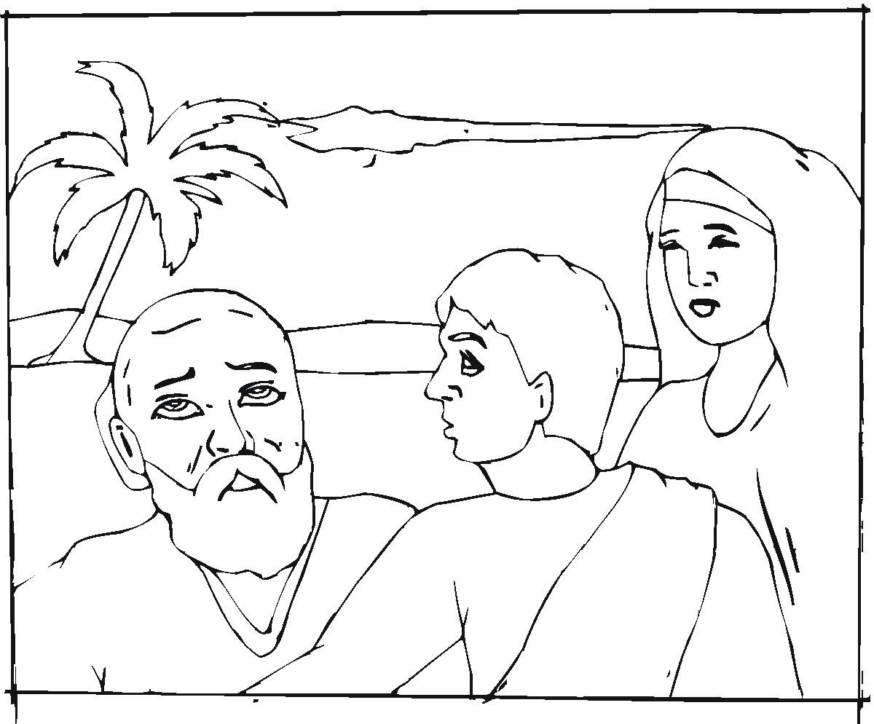
⁴¹ Esau was angry with Jacob. He was angry because of the blessing his father had given to Jacob. He said to himself, "My father will soon die. The days of sorrow over him are near. Then I'll kill my brother Jacob." ⁴² Rebekah was told what her older son Esau had said. So she sent for her younger son Jacob. She said to him, "Your brother Esau is comforting himself with the thought of killing you. ⁴³ "Now then, my son, do what I say. Go at once to my brother Laban in Haran. ⁴⁴ Stay with him until your brother's anger calms down. ⁴⁵ Stay until your brother isn't angry with you anymore. When he forgets what you did to him, I'll let you know. Then you can come back from there. Why should I lose both of you in one day?" ⁴⁶ Then Rebekah spoke to Isaac. She said, "I'm sick of living because of Esau's Hittite wives. Suppose Jacob also marries a Hittite woman. If he does, my life won't be worth living." ¹ So Isaac called for Jacob and blessed him. He commanded him, "Don't get married to a woman from Canaan. ² Go at once to Paddan Aram. Go to the house of your mother's father Bethuel. Find a wife for yourself there. Take her from among the daughters of your mother's brother Laban. ³ "May the Mighty God bless you. May he give you children. May he increase your numbers until you become a community of nations. ⁴ May he give you and your children after you the blessing he gave to Abraham. Then you can take over the land where you now live as an outsider. It's the land God gave to Abraham." ⁵ Isaac sent Jacob on his way. Jacob went to Paddan Aram. He went to Laban, the son of Bethuel the Aramean. Laban was the brother of Rebekah. And Rebekah was the mother of Jacob and Esau.

- Describe Rebekah’s scheme to intercept Isaac’s plans.

- What kind of an example was she being to Jacob?

- How do parents today often give their children wrong examples or mixed signals?

- How would you describe the communication between husband and wife here?

- What can you infer about Rebekah’s relationship to Esau?

- What price was she willing to pay to get what she wanted?

- If Rebekah had been interested in fulfilling God’s plans for Jacob, how might she have handled the situation differently?

- How much respect did she show for Isaac?

- Why is respect so important in a marriage?

- Coached by his mother, how did Jacob succeed in deceiving his father?

- How did he use God to back up his lies?

- What did Jacob gain? (27:27-29)

- Does this account teach us that the end justifies the means? Why or why not?

- What did Rebekah have to do to rescue Jacob from Esau’s revenge?

- How did she explain her next plan to Isaac?

- Why did Isaac concur with Rebekah’s plan?

- How would you describe Rebekah as a wife and mother to her two sons?

- How could she have re-established communication with her husband?

- How could she have shown appreciation for Esau?

- What did she really gain by her selfishness and bias toward Jacob?

- How was Jacob affected by his mother’s attitude?

- Why do you think this home, which began with so much faith and promise, fell apart?

- What specific warnings can you learn from this family to apply to your own home situation?

Closing Prayer: Dear Lord, thank you for revealing the details of the life of Rebekahl. As the proverb says (Proverbs 14:1) “A wise woman builds her house. But a foolish woman tears hers down with her own hands” that is just what Rebekah did. Help me to learn that even in the most difficult of situations to be honest and upright with all people, especially those I love the most and help me to follow your Word and your will. Thank you for dying for me and for paying for all of my sins. Help me to make changes in my life so that I can better serve you and live in accord with your Word. In Jesus’ name I ask it. Amen.

Scripture taken from the Holy Bible, NEW INTERNATIONAL READER'S VERSION®.Copyright © 1996, 1998 Biblica. All rights reserved throughout the world. Used by permission of Biblica.

