WOMEN OF THE BIBLE – HULDAH

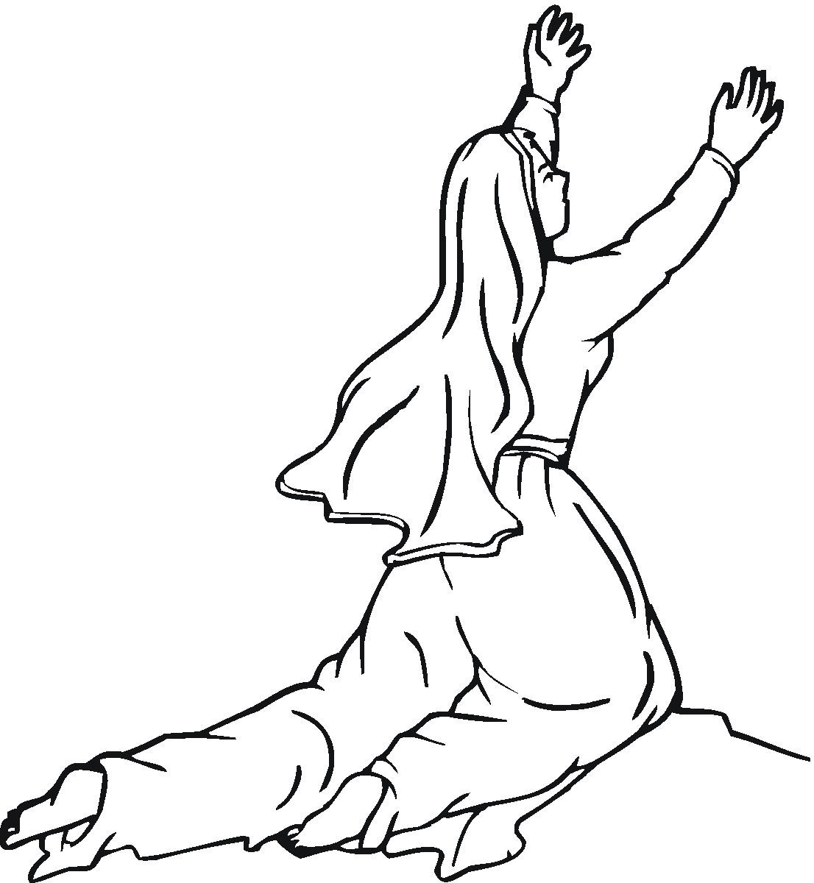
PRAYER: O Lord God, heavenly Father, you have called sinful human beings to be your servants. Thank you for women like Huldah. Guide me in such a way that even if all those around me reject you and your Word I might remain your faithful servant. Help me to believe that all my sins were paid for by Jesus my Savior and the Holy Spirit is at work through the Word to strengthen me in my faith and in my life. I ask it in Jesus’ name. Amen.

INTRODUCTION: The women of the Bible make an interesting study of faith and life. Like every woman they all carry the baggage of sin on their shoulders. In this study we will see how the Lord used a faithful mother to pass on his word to future generations.

BACKGROUND: After Kings David and Solomon the nation of Israel was divided into two parts. The northern ten tribes were called Israel and the southern two tribes were called Judah. The people of Judah were more faithful to the Lord than Israel, but certainly far from what one would expect. King Josiah’s grandfather was Manasseh, the most wicked king in Judah’s history. He was compared to Israel’s Ahab for the idolatry he practiced and promoted in the nation, for the innocent people he murdered, and for his total rebellion against the Lord, Jehovah. Manasseh reigned fifty-five years. His son, Amon, reigned only two years, but he followed the evil ways of his father. Then young Josiah came to the throne.

Read 2 Kings 22:1 – 23:25: Hilkiah Finds the Scroll of the Law
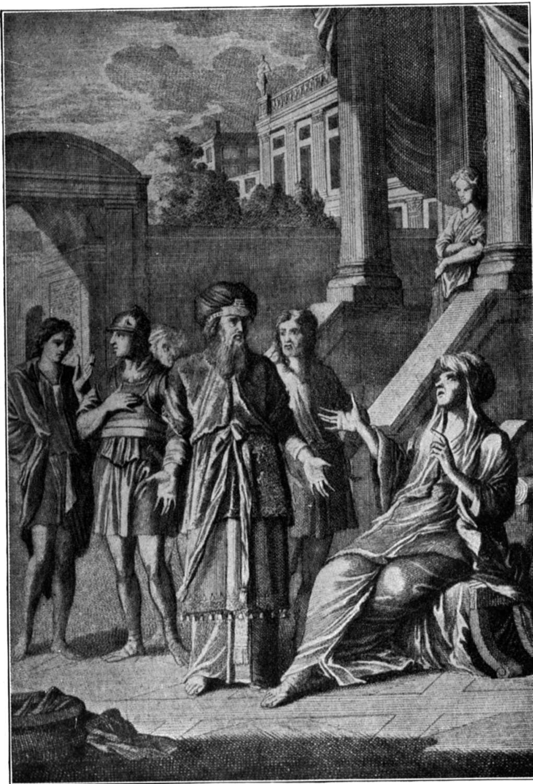
¹ Josiah was eight years old when he became king. He ruled in Jerusalem for 31 years. His mother's name was Jedidah. She was the daughter of Adaiah. She was from Bozkath. ² Josiah did what was right in the eyes of the Lord. He lived the way King David had lived. He didn't turn away from it to the right or the left. ³ King Josiah sent his secretary Shaphan to the Lord's temple. It was in the 18th year of Josiah's rule. Shaphan was the son of Azaliah. Azaliah was the son of Meshullam. Josiah said, ⁴ "Go up to the high priest Hilkiah. Have him add up the money that has been brought into the Lord's temple. Those who guard the doors have collected it from the people. ⁵ "Have them put all of the money in the care of the men who have been put in charge of the work on the Lord's temple. Have them pay the workers who repair it. ⁶ Have them pay the builders and those who work with wood. Have them pay those who lay the stones. Also have them buy lumber and blocks of stone to repair the temple. ⁷ "But they don't have to report how they use the money that is given to them. That's because they are completely honest." ⁸ The high priest Hilkiah spoke to the secretary Shaphan. He said, "I've found the Scroll of the Law in the Lord's temple." He gave it to Shaphan, who read it. ⁹ Then Shaphan went to King Josiah. He told him, "Your officials have paid out the money that was in the Lord's temple. They've put it in the care of the workers and directors there." ¹⁰ Shaphan continued, "The priest Hilkiah has given me a scroll." Shaphan read some of it to the king. ¹¹ The king heard the words of the Scroll of the Law. When he did, he tore his royal robes. ¹² He gave orders to the priest Hilkiah, Ahikam, Acbor, the secretary Shaphan and Asaiah. Ahikam was the son of Shaphan. Acbor was the son of Micaiah. And Asaiah was the king's attendant. Josiah commanded them, ¹³ "Go. Ask the Lord for advice. Ask him about what is written in this scroll that has been found. Do it for me. Also do it for the people and the whole nation of Judah. The Lord's anger is burning against us. That's because our people before us didn't obey the words of this scroll. They didn't do everything that is written there about us." ¹⁴ The priest Hilkiah went to speak to the prophet Huldah. So did Ahikam, Acbor, Shaphan and Asaiah. Huldah was the wife of Shallum. Shallum was the son of Tikvah. Tikvah was the son of Harhas. Shallum took care of the sacred robes. Huldah lived in the New Quarter of Jerusalem. ¹⁵ She said to them, "The Lord is the God of Israel. He says, 'Tell the man who sent you to me, ¹⁶ "The Lord says, 'I am going to bring horrible trouble on this place and its people. Everything that is written in the scroll the king of Judah has read will take place. ¹⁷ "'" 'That is because the people have deserted me. They have burned incense to other gods. They have made me very angry because of the statues of gods their hands have made. So my anger will burn against this place. The fire of my anger will not be put out.'"' ¹⁸ "The king of Judah sent you to ask the Lord for advice. Tell him, 'The Lord is the God of Israel. He has a message for you about the things you heard. He says, ¹⁹ "Your heart was tender. You made yourself low in my sight. You heard what I spoke against this place and its people. I said they would be under a curse. I told them they would be destroyed. You tore your royal robes and sobbed. And I have heard you," announces the Lord. ²⁰ "'"You will join the members of your family who have already died. Your body will be buried in peace. Your eyes will not see all of the trouble I am going to bring on this place."'" Huldah's answer was taken back to the king.

Josiah Promises to Follow the Covenant
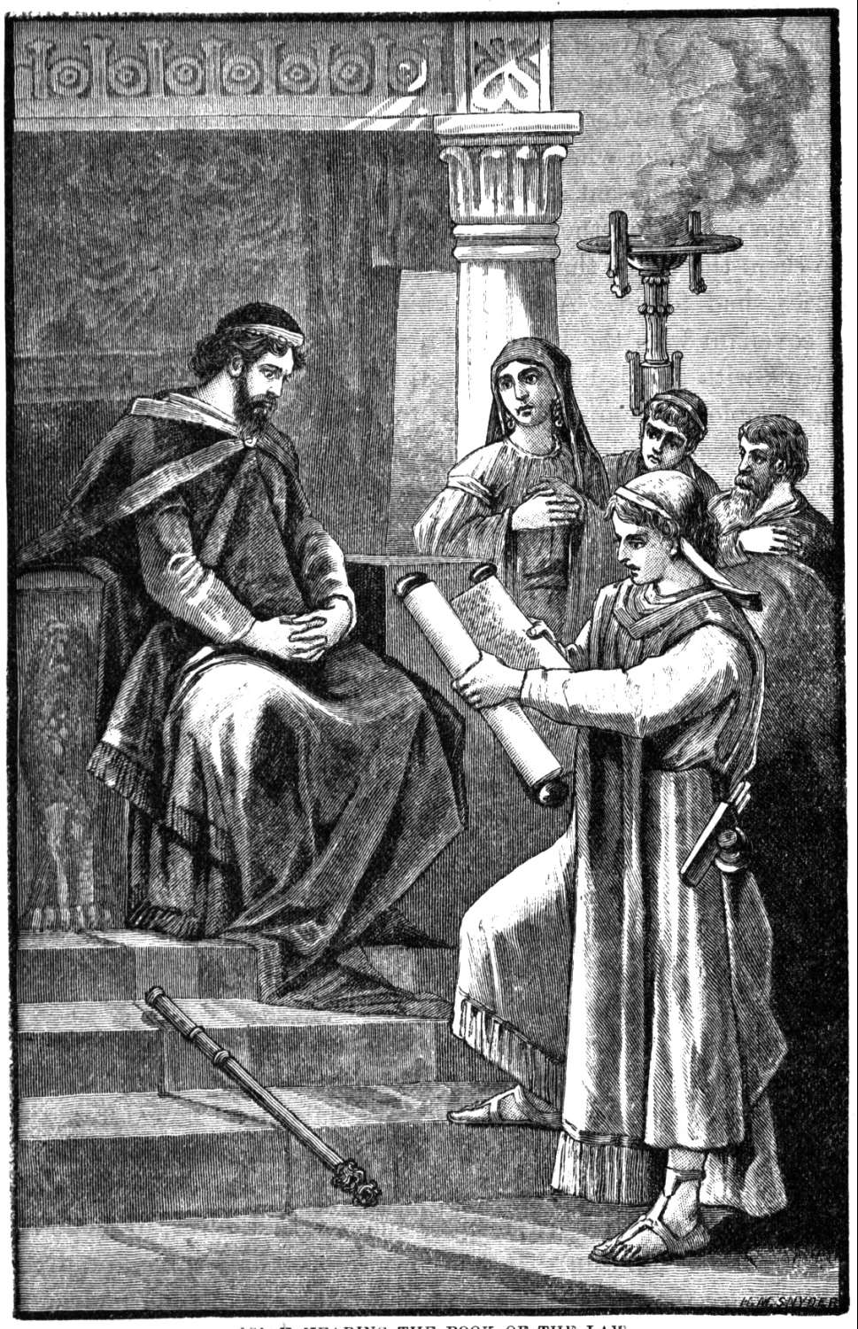
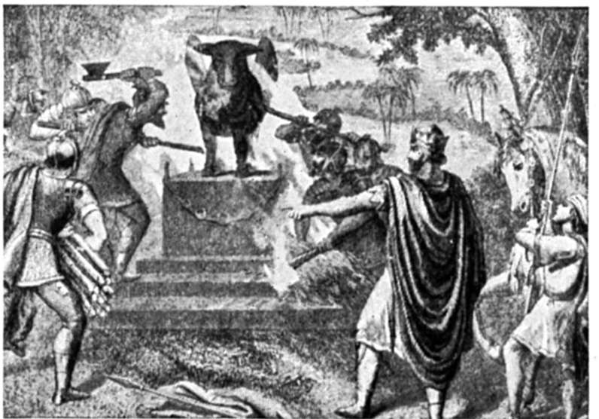
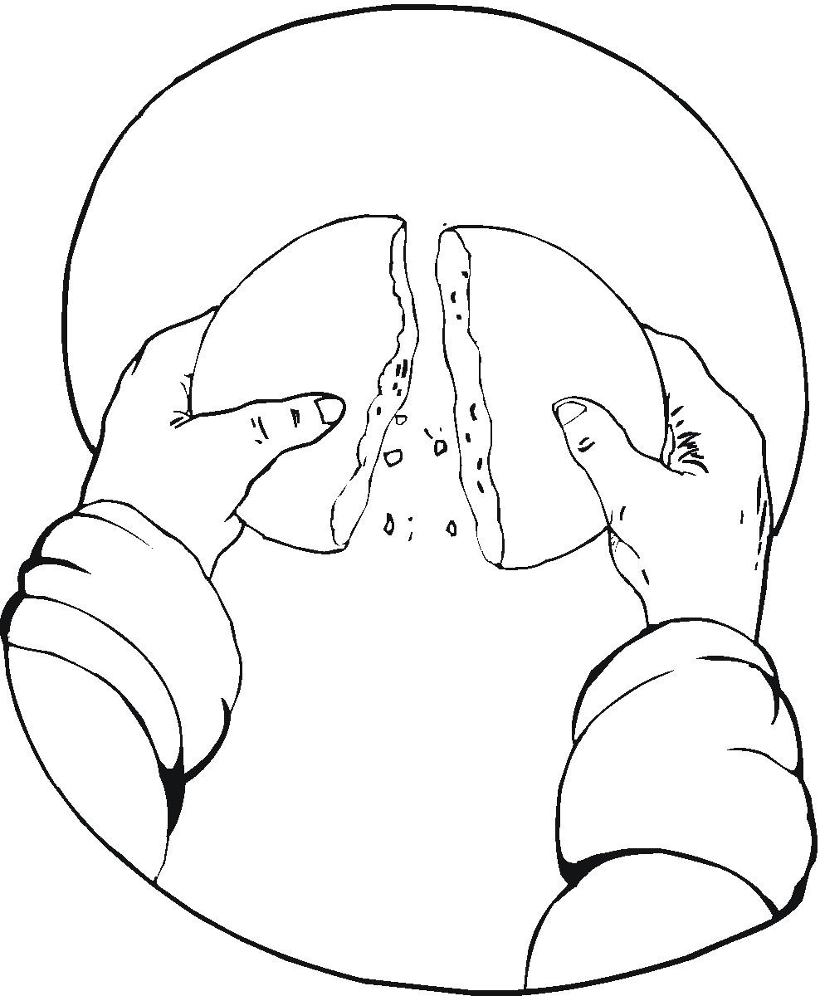
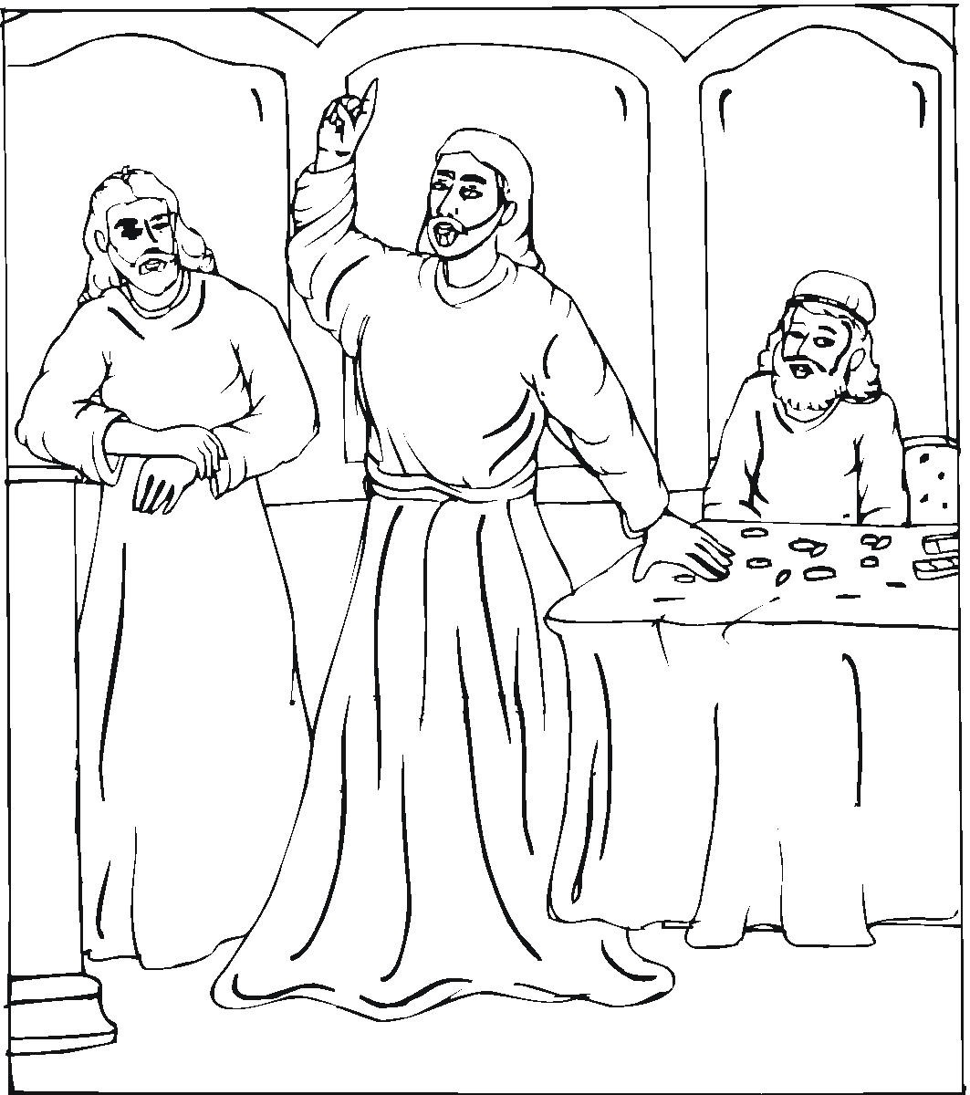
¹ Then the king called together all of the elders of Judah and Jerusalem. ² He went up to the Lord's temple. The people of Judah and Jerusalem went with him. So did the priests and prophets. All of them went, from the least important of them to the most important. The king had all of the words of the Scroll of the Covenant read to them. The scroll had been found in the Lord's temple. ³ The king stood next to his pillar. He agreed to the terms of the covenant in front of the Lord. He promised to follow him and obey his commands, directions and rules. He promised to obey them with all his heart and with all his soul. So he agreed to the terms of the covenant that were written down in that scroll. Then all of the people committed themselves to the covenant. ⁴ Certain articles that were in the Lord's temple had been made to honor the god Baal and the goddess Asherah and all of the stars in the sky. The king ordered the high priest Hilkiah to remove those articles. He ordered the priests who were under him and the men who guarded the doors to help Hilkiah. Josiah burned the articles outside Jerusalem. He burned them in the fields in the Kidron Valley. And he took the ashes to Bethel. ⁵ He got rid of the priests who served other gods. The kings of Judah had appointed them to burn incense. They burned the incense on the high places of the towns of Judah. And they burned it on the high places around Jerusalem. They burned incense to honor Baal and the sun and moon. They burned it to honor all of the stars. ⁶ Josiah removed the Asherah pole from the Lord's temple. It had been used to worship Asherah. He took it to the Kidron Valley outside Jerusalem. There he burned it. He ground it into powder. And he scattered it over the graves of the ordinary people. ⁷ He also tore down the rooms where the male temple prostitutes stayed. Those rooms were in the Lord's temple. The women had made cloth for Asherah in them. ⁸ Josiah brought all of the priests from the towns of Judah and destroyed the high places. He destroyed them from Geba all the way to Beersheba. The priests had burned incense on them. Josiah broke down the high places at the gates. That included the high place at the entrance of the Gate of Joshua. It was on the left side of one of Jerusalem's gates. Joshua was the city governor. ⁹ The priests of the high places didn't serve at the Lord's altar in Jerusalem. In spite of that, they ate with the other priests. All of them ate bread that was made without yeast. ¹⁰ Josiah destroyed the high places at Topheth in the Valley of Ben Hinnom. He didn't want anyone to use them to sacrifice his son or daughter in the fire to the god Molech. ¹¹ He removed the statues of horses from the entrance to the Lord's temple. The kings of Judah had set them apart to honor the sun. The statues were in the courtyard. They were near the room of an official named Nathan-Melech. Josiah burned the chariots that had been set apart to honor the sun. ¹² He pulled down the altars the kings of Judah had set up. They had put them on the palace roof near the upstairs room of Ahaz. Josiah also pulled down the altars Manasseh had built. They were in the two courtyards of the Lord's temple. Josiah removed the altars from there. He smashed them to pieces. Then he threw the broken pieces into the Kidron Valley. ¹³ The king also destroyed the high places that were east of Jerusalem. They were at the southern end of the Mount of Olives. They were the ones Solomon, the king of Israel, had built. He had built a high place for worshiping Ashtoreth. She was the evil goddess of the people of Sidon. Solomon had also built one for worshiping Chemosh. He was the evil god of Moab. And Solomon had built one for worshiping Molech. He was the god of the people of Ammon. The Lord hated that god. ¹⁴ Josiah smashed the sacred stones. He cut down the poles that were used to worship the goddess Asherah. Then he covered all of those places with human bones. ¹⁵ There was an altar at Bethel. It was at the high place that had been made by Jeroboam, the son of Nebat. Jeroboam had caused Israel to commit sin. Even that altar and high place were destroyed by Josiah. He burned the high place. He ground it into powder. He also burned the Asherah pole. ¹⁶ Then Josiah looked around. He saw the tombs that were on the side of the hill. He had the bones removed from them. And he burned them on the altar to make it "unclean." That's what the Lord had said would happen. He had spoken that message through a man of God. The man had announced those things long before they took place. ¹⁷ The king asked, "What's that stone on the grave over there?" The men of the city said, "It marks the tomb where the body of a man of God is buried. He came from Judah. He spoke against the altar at Bethel. He announced the very things you have done to it." ¹⁸ "Leave it alone," Josiah said. "Don't let anyone touch his bones." So they spared his bones. They also spared the bones of the prophet who had come from the northern kingdom of Israel. ¹⁹ Josiah did in the rest of the northern kingdom the same things he had done at Bethel. He removed all of the small temples at the high places. He made them "unclean." The kings of Israel had built them in the towns of the northern kingdom. The people in those towns had made the Lord very angry. ²⁰ Josiah killed all of the priests of those high places on the altars. He burned human bones on the altars. Then he went back to Jerusalem. ²¹ The king gave an order to all of the people. He said, "Celebrate the Passover Feast to honor the Lord your God. Do what is written in this Scroll of the Covenant." ²² A Passover Feast like that one had not been held for a long time. There hadn't been any like it since the days of the judges who led Israel. And there hadn't been any like it during the whole time the kings of Israel and Judah were ruling. ²³ King Josiah celebrated the Passover in Jerusalem to honor the Lord. It was in the 18th year of his rule. ²⁴ And that's not all. Josiah got rid of those who got messages from people who had died. He got rid of those who talked to the spirits of the dead. He got rid of the statues of family gods and the statues of other gods. He got rid of everything else the Lord hates that was in Judah and Jerusalem. He did it to carry out what the law required. That law was written in the scroll the priest Hilkiah had found in the Lord's temple. ²⁵ There was no king like Josiah either before him or after him. None of them turned to the Lord as he did. He followed the Lord with all his heart and all his soul. He followed him with all his strength. He did everything the Law of Moses required.

QUESTIONS:
- After such a long history of idolatry and rebellion toward God on the part of Judah’s king, who do you think so influenced Josiah that he made such a drastic change of direction (22:1-2)?

- How do we know there were some people still loyal to the Lord (22:7)?

- What was Josiah’s immediate reaction when the book of the law, which had been discovered in the temple, was read to him (22:11-13)?

- To whom did the high priest and the king’s representatives to inquire of the Lord for King Josiah (22:14)? In what location?

- What were Huldah’s credentials? By whose authority did she speak? How did she refer to the king in 22:15, 18? Why?

- How did her message from the Lord verify the warning Josiah had read in the book (22:17, 19)? What penalties did the nation face?

- Why would it take courage for Huldah to transmit this strong warning to the king?

- What message of personal consolation did she have for King Josiah?

- How did the king’ representatives show their respect for Huldah’s prophecy?

- What was Josiah immediate response (2 Kings 23) to Huldah’s message?

- How did King Josiah remedy the ignorance of the people toward the law of God?

- What promise did Josiah make to God? Who joined him in that commitment?

- Have you ever made promises to God? Explain. How well did you keep them?

- Why was it significant that so many people, pagan objects and practices had to be destroyed and forsaken (23:4-20)?

- What was the purpose of keeping the Passover?

- What made Josiah’s Passover exceptional?

- In what other way did Josiah obey God’s law (23:24)?

- How do Christians keep the Passover today?

- What part did Huldah’s influence have in Josiah’s life and thus in the spiritual reform of the nation?

- What might have happened if Huldah had not met the challenge and spoken out?

- Have you ever had the opportunity to speak out against evil and for God? Explain.

- On what can we base our confidence if we speak out for the truth of God?

SUMMARY: In a time of crisis and deep need in the kingdom of Judah, it was a woman, Huldah, who was so in touch with God that she was ready to speak for him and who had the courage to be honest. Because of her, the king learned what he and his nation needed to do – to turn from sin and follow God’s instructions, thus averting for a time the judgment and punishment which they had deserved.

Closing Prayer: Dear Lord, thank you for revealing that you can use the gifts of all men and women for your glory and the extension of your kingdom. Thank you for dying for me and for paying for all of my sins. Help me to make changes in my life so that I can better speak up in confidence and live in accord with your Word. In Jesus’ name I ask it. Amen.

Scripture taken from the Holy Bible, NEW INTERNATIONAL READER'S VERSION®.Copyright © 1996, 1998 Biblica. All rights reserved throughout the world. Used by permission of Biblica.

